Unit 2 Social Studies Vocabulary Words

1 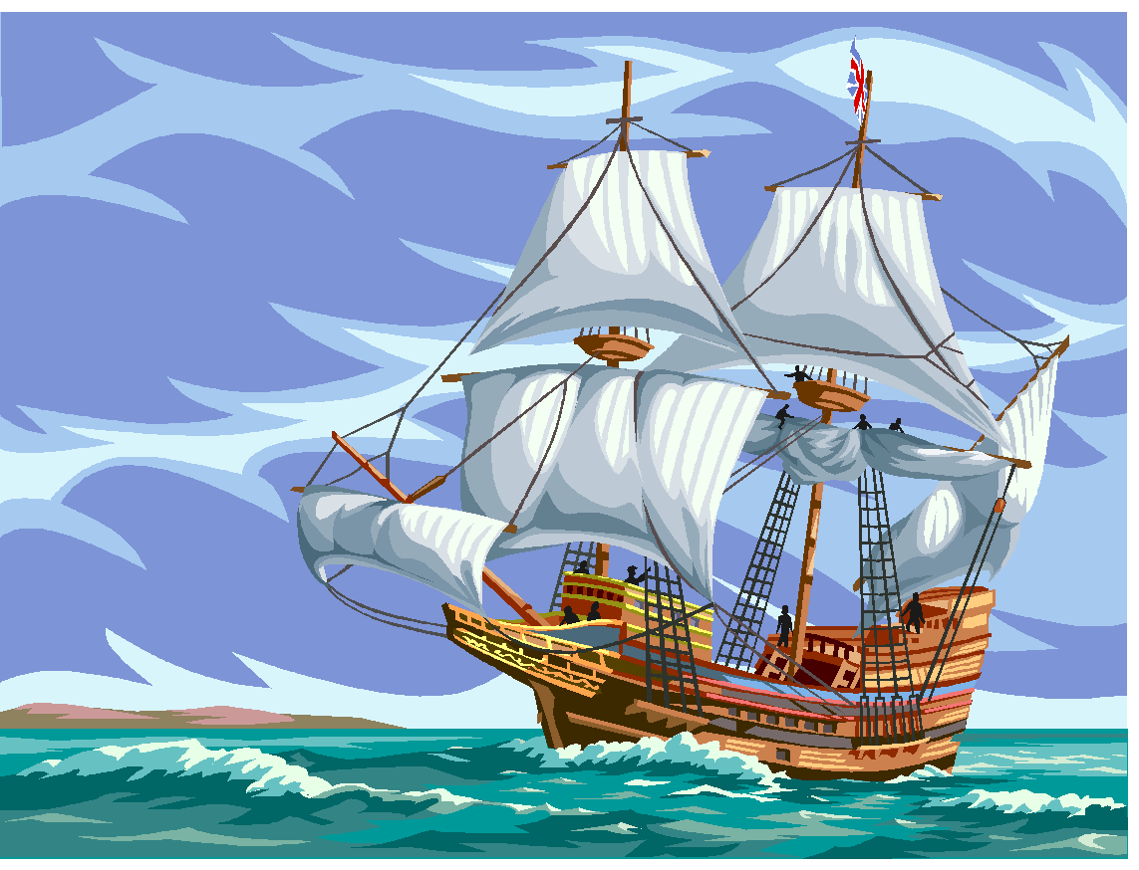  history  the study of the past  Example: When you study history you study about people and events of the past.  (SS050201) | 2  historian  a person who studies the past  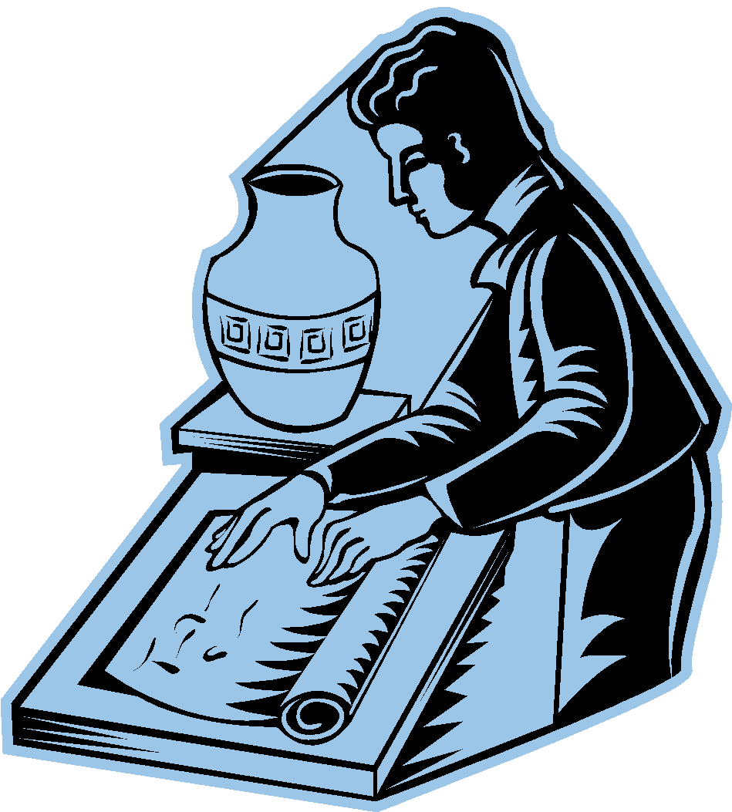  Example: A historian studies clues from the past.  (SS050201)
3  primary sources  records made by people who saw or took place in an event  Example: Photographs, diaries, newspaper articles and letters are primary sources.  (SS050201) | 4  secondary  sources  records written by someone who was not there at the time of the event  Example: Textbooks are secondary sources  (SS050201)
5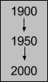  chronological  order  time sequence  Example: He put the events in Michigan history in chronological order.  (SS050201) | 6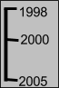  timeline  a diagram that shows the  order in which events happened  Example: You can make a timeline of important events in your life.  (SS050201)

7  century  100 years  Example: The timeline showed four centuries.  (SS050201) | 8  point of view  how a person looks at a problem or an event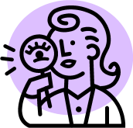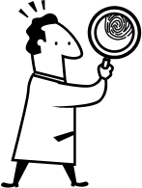  Example: People can have different points of view because their ages or backgrounds are different.  (SS050201)
9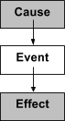  cause  an action that  makes something else  happen  Example: One cause of population growth in Michigan was the opening of the Erie Canal.  (SS050201) | 10  effect  something that results  from something  else happening  Example: One effect of the fur trade in Michigan was that American Indians and the French began to interact.  (SS050201)

