1. **Confederation**- a group of leaders who work together for the benefit of their members

***Example*:**  The Haudenosaunee League was a confederation made up of five nations.

1. **Geography**-the study of the Earth and the way people interact with the Earth

***Example*:**  When you study geography you learn about different places.

1. **Region-** an area that has one or more features in common

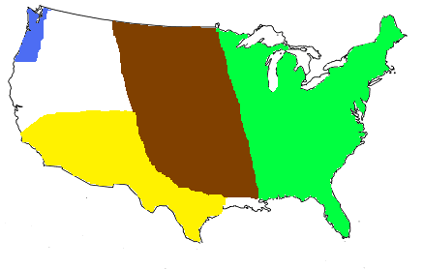

***Example*:**  The Southwest and the Pacific Northwest are two examples of American Indian regions.

1. **Culture**-the way of life for a group of people



***Example*:**  The culture of the American Indians of the Southwest included eating corn, having ceremonies in hopes of a good harvest, and arts such as pottery and weaving.

1. **Human/environment interaction**- ways in which people use, adapt to, or modify their environment.

***Example*:**  When people of the Pacific Northwest used trees for houses and other things in their culture, they were interacting with their environment.

1. **text features-** things that can help a reader understand what they read

***Example*:**  Text features include highlighted text, headings, and bulleted text.

1. **Exploration-** to travel in order to discover something 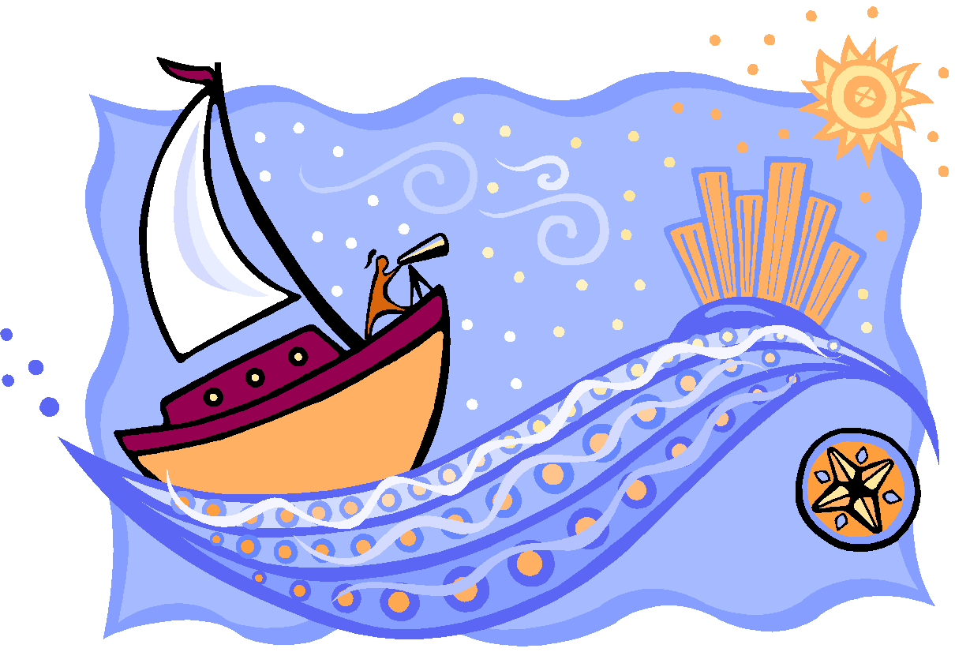

***Example*:**  People from Europe began exploration of the Americas.

1. **Navigation-** the science of determining a ship’s location and direction

***Example*:**  One reason European sea exploration increased, was improved methods of navigation.