Author Study Project

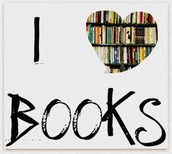
You’ve been reading and reading all these fantastic books, but do you know the person behind all of those creative words? Time to get to know more about your favorite author!

In this homework assignment, you will have 3 weeks to research, write, and be ready to present your findings. I expect that you manage your time wisely. Please do the required work, and at least one of the choice options. Enjoy!

Tasks:

1st- Choose an author you love! You must have read at least 2 books by this author (or will be currently reading the second to learn more about their style).

2nd- Research using the internet and books to find more information about your author. You will need this for the Research Report below.

3rd- Choose a Creative Element to add to your project. You must choose at 1.

All pieces of the project are DUE on ________________

If you need help with time management, use this guideline to help you. We will check in each Friday to see how far you are and what help you need:

Week: | Task: | Done by:
Week 1 | Choose an author, decide on your key focus questions, find resources and start researching
Week 2 | Continue research, start writing Research Report, and choose your Creative Element
Week 3 | Finish writing Research Report and Creative Element. Practice presenting to be ready for class.

Research Report- REQUIRED (TYPED in appropriate, easy to read 12-point font. No weird fonts. Seriously. If you’re not sure, ask me.)

Outline

Use this guideline to help you write your 5 paragraph report. If you have more information than can fit in 5 paragraphs, you may write multiple paragraphs for a section if needed. You do not need to answer every question or in that order, but they are just helpful to get your ideas flowing.

1st Paragraph- Introduction:
- Why did you choose this author?
- What books you have read by him/her?
- What is the genre of writing and target audience for your author?
- What do you love about this author’s writing style?
- In your opinion, why is he/she such a great author?

2nd Paragraph- Professional Life:
- What are the names of the popular books your author is known for?
- Does he/she like to write series, or a lot of different style books?
- How did he/she become an author?
- Where did your author attend school? What degrees does he/she hold?
- Did your author have any other jobs?
- What book do you know, or believe, is the artist’s favorite, and why?
- What parts of creating books come easily to your artist? Which parts are difficult?
- Is there anything that is a special inspiration to your author?

3rd Paragraph- Personal Life:
- When was your author born (date, year)? How old is your author?
- Where did your author grow up and where do they live now? (If different)
- Does he/she have any children?
- Does he/she have any pets?
- What does your author like to do in his or her personal time?
- Can you give any examples of the artist’s family, pets, personal experiences or interests appearing in or affecting his or her work?

4th Paragraph- Favorite Books Spotlight:
- Give a brief summary for each of the two (or more) books that you have read by this author.
- Do they have similar themes between books?
- What connections can you make between the books? Similar characters? Plot elements? Illustration styles on the covers? Etc.
- What elements do you like most about their writing style?

5th Paragraph- Author Writing Style:
- How does the author get their ideas?
- How do they draft typically? Any routines they follow?
- What process do they go through for editing and revision?
- What advice (if any) do they give to young authors about writing?
- How can you take elements of their writing to use as inspiration for your own?
- If you had to say in a few sentences what your author does in books that makes him/her different than any other author, what would you say? (In other words, be able to describe the author’s style and favorite themes.)
- Leave us with a closing line that makes us want to go pick up one of your author’s books and start reading!

Choice Element- Choose 1 from the options below:

- Letter to the author- Write a detailed fan letter to the author explaining why you like their books, how they’ve inspired you as a writer, and maybe even some ideas to include in new books they should write!
- PowerPoint Presentation- Make a minimum of 5 slide presentation about your author to share with the class. Include some of the elements from your research report.
- Poster- Create a poster with visuals and paragraphs about your author’s professional and personal life, including info about their most popular books.
Web Resources:

Check out these great internet sites for resources about your author. Don’t forget to look up videos as you can often find famous authors speaking about their writing process or how they came to be an author.

How to do Research (All the Steps Involved)
http://www.kyvl.org/kids/homebase.html

Reading book reviews by other students and writing a book review to submit online:
http://teacher.scholastic.com/activities/swyar/browse.asp

Researching Authors Sites:
http://www.proteacher.com/070081.shtml
http://www.kidsreads.com/authors/authors.asp
http://dir.yahoo.com/Arts/Humanities/Literature/Authors/Children_s/
http://webtech.kennesaw.edu/jcheek3/authors.htm
http://ettc.lrhsd.org/archives/author.shtml
http://www.scholastic.com/librarians/ab/biolist.htm

Audio and Video Clips:

http://www.readingrockets.org/books/interviews/
AdLit.org
YouTube.com (Get permission from parents before using YouTube)
iTunes (Podcasts and Vodcasts in the iTunes Store or iTunesU)

** Websites and videos will probably be the best up-to-date resources but make sure to use what information you already have inside and on the back of your book covers. There’s a lot of information to help you with a starting place. **
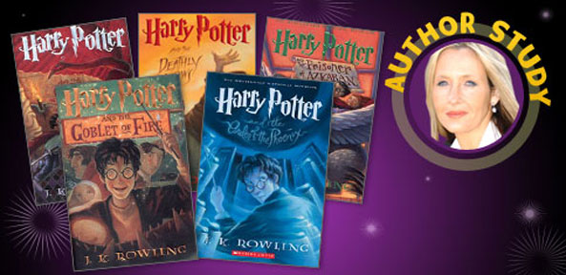

Research Notes: Record notes below to help organize your ideas.
Professional Life:  - Popular Books  - Awards Won  - College Attended  - How He/She Got Into Writing  - Inspirations | ____________________________________________________________________________________________________________________________________________________________________________________________________________________________________________________________________________________________________________________________________________________________________________________________________________
Personal Life:  - Birthday/Age  - Cities Lived In  - Children  - Pets  - Interests/Hobbies  - Hobbies/Experiences Related to Stories  Favorite Books Spotlight:  - Book #1- ________________________________  - Book #2-  - ________________  ________________  - Write Summaries  - Connections  - Themes  - Surprises | ____________________________________________________________________________________________________________________________________________________________________________________________________________________________________________________________________________________________________________________________________________________________________________________________________________  ____________________________________________________________________________________________________________________________________________________________________________________________________________________________________________________________________________________________________________________________________________________________________________________________________________  _________________________________
Author Writing Style:  - Ideas  - Writing Process  - Editing/Revision  - Advice?  - What makes them different | _____________________________________________________________________________________________________________________________________________________________________________________________________________________________________________________________________________________________________________________________________________________________________________________________________________________________________________

Extra Notes:  Put Topic on this Side, Info on Right Side | ______________________________________________________________________________________________________________________________________________________________________________________________________________________________________________________________________________________________________________________________________________________________________________________________________________________________________________________________________________________________________________________________________________________________________________________________________________________________________________________________________________________________________________________________________________________________________________________________________________________________________________________________________________________________________________________________________________

Works Cited (Also Known As A Bibliography)
Record your book and web resources below with the approximate date accessed (viewed/read).
Date: | Book Title/Author and/or Website Title/URL (www._______.com)

