Honors Algebra 2 Name ____________________

13-2 Measures of Central Tendency Date _____________ Hour ___

Use the table below. Find the mean, median, and mode(s) of each set of data.

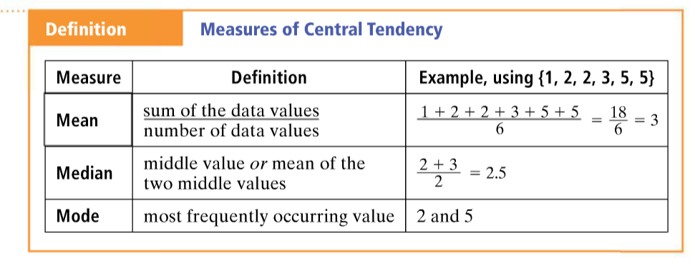

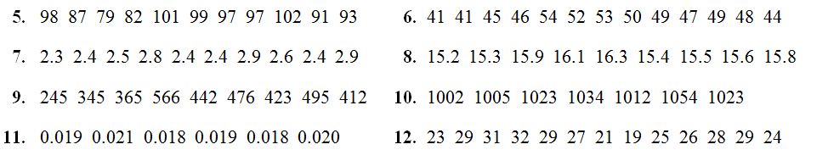 Honors

Algebra 2 Name ____________________

13-2 Measures of Central Tendency Date _____________ Hour ___

Use the table below. Find the mean, median, and mode(s) of each set of data.



