Honors Algebra 2 Name _____________________

Hold Up Your Answers Review 6.1-6.1 Date ________________ Hour __

1. Write polynomial in standard form and classify it accordingto its degree and

number of terms.

**(3x3 - 2x2 + 7) - (5x2 - 3x3 + 1)**

2. Write the polynomial in standard form.

**(x + 2)(x - 3)(x + 6)**

3. Write the polynomial in factored form.

**2x3 - 2x2 - 40x**

4. Determine the end behavior of each function.

a) **f(x) = -3x2 - 2x + 4**

b) **f(x) = 4x3 - 3x + 2**

5. For the polynomial function, find and label the zeros. Then sketch the graph.

**y = -(x - 2)(x + 5)(x - 6)**

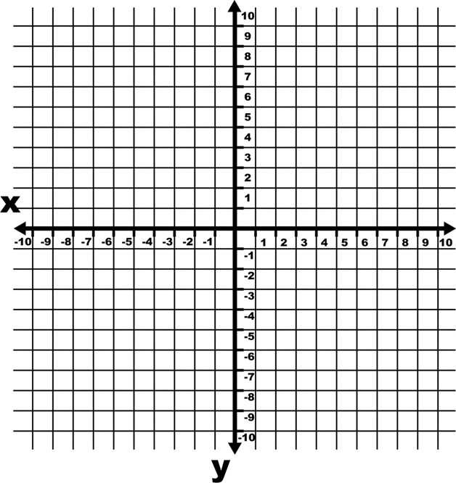

6. For the polynomial function, find and label the zeros. Then sketch the graph.

**y = x2 + 2x - 15**



7. Write the polynomial function in standard form with zeros: -2, 0, 0, 3

8. For the function, determine the zeros. State the multiplicity of any multiple zeros.

**f(x) = x4 - 4x3 + 4x2**