**Honors Algebra 2 Name ______________________________**

**Final Exam – Part 5 Date ____________________ Hour ______**

**\*\*This is part of your exam grade.\*\***

1. An object is launched directly upward at 64 feet per second (ft/s) from a platform 80 feet high.

The equation ***h*(*t*) = –16*t* ² + 64*t* + 80** models the height of the object after **t** seconds. What

will be the object's maximum height? When will it attain this height?

2. A ball is shot into the air form the edge of a building 50 feet above the ground. Its initial velocity is

20 feet per second. The equation **h = -16t² + 20t + 50** can be used to model the height of the

ball after **t** seconds. About how long does it take for the ball to hit the ground?

3. The exponential functions below both have the x-axis, (y = 0) as an **asymptote** since both graphs

approach the x-axis but will never touch it.

a) What other parent function has an asymptote?

b) What is the equation for the asymptote?

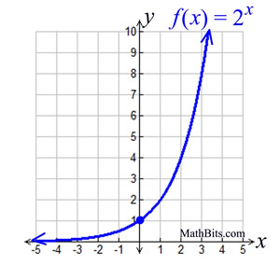 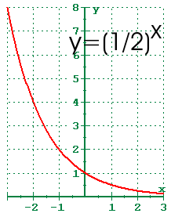

4. Simplify each expression. Write your answers in simplest complex form, **a + bi**.

a) (-3 + 2i) – (14 – 3i) b) (17 – 12i) + (-10 – 2i) c) -7i(8) d) (5i)(-3i)

5. Simplify the following rational expression. (Factor both terms.) For which values of x is the

function not defined?

6. Solve and check each quadratic equation.

a) **2x² + 6x + 7 = 0** b) **x² - 14x = 32**

c) **x² - 2x + 3 = 0** d) **3x² - 4 = 71**

e) **-2x² = 4x + 3** f) **-2x² = 72**

7. Solve and check each radical equation.

a) $2+ \sqrt{3x-2}=6$ b) $\sqrt{x-3}+5=x$