Honors Algebra 2 Name ________________________________________

Final Exam Review – Part 2

**THIS REVIEW IS PART OF YOUR EXAM GRADE**

**Unit 2: Function Families and Transformations**

1) **NC** Draw a rough sketch and write the equation for each of the parent functions.

|  |  |  |  |
| --- | --- | --- | --- |
| a) Linear  Equation: _______________  Image result for coordinate graph | b) Absolute Value  Equation: _______________  Image result for coordinate graph | c) Quadratic  Equation: _______________  Image result for coordinate graph | d) Square Root  Equation: _______________  Image result for coordinate graph |
| e) Cubic  Equation: _______________  Image result for coordinate graph | f) Cube Root  Equation: _______________  Image result for coordinate graph | g) Exponential Growth  Equation: _______________  Image result for coordinate graph | h) Logarithmic  Equation: _______________  Image result for coordinate graph |

2) **NC** f(x)=a(x - h)2 + k What happens to the function when….

|  |  |  |
| --- | --- | --- |
| |a|>1 | h>0 | k>0 |
| 0<a<1 | h<0 | k<0 |
| a<0 |

3) **NC** Find the requested information for the graph below. Make sure you use the correct parentheses

and/or brackets.

Increasing: Decreasing:

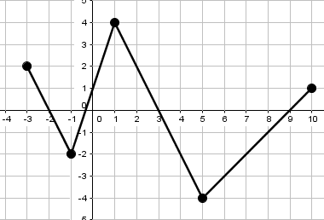

Domain: Range:

4) **NC** For each graph below, list the transformations. Then, write the equation for the graph.

|  |  |
| --- | --- |
| a) Transformations:       New Equation: | b) Transformations:       New Equation: |

5) Find the domain & range for the following 2 functions: (Hint: It might help to draw a rough sketch!)

a) $f\left(x\right)=3{\left(x-2\right)}^{2}-5$ b)

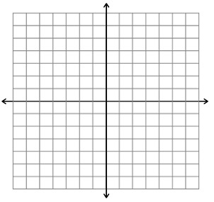

Honors Algebra 2 Name ________________________________________

Final Exam Review – Part 1

**THIS REVIEW IS PART OF YOUR EXAM GRADE**

**Unit 1: Systems of Equations**

1) **NC** Solve the system by graphing. 2) **NC**  Solve the system using any method.

 5x + 3y = 9 5x + y = 9

x - 3y = 9 10x + 2y = 20

3) Graph the following system of inequalities. 4) Are the points below a solution to

 $y<-3x-4$ $5x+3y≥9$?

$y≥\frac{1}{2}x+3$ a. (-2, 10) b. (2, -3) c. (4, 3) d. (1, 1)

5) Amina is hosting a party. She places an order at Pizza Hut for 5 pizzas and 4 orders of breadsticks for

a total of $51.00. Halfway through the party, she realizes that she will need one more pizza and 2

more orders of breadsticks. This time her total is $15.00. Write and solve a system of equations to

find the cost of each pizza and each order of breadsticks.

6) **NC** Mya is selling cookies (x) and brownies (y) at a bake sale. One cookie costs $1.50 and a brownie

costs $2.00. She needs to make at least $50 to make a profit but she only has 20 cookies to sell. Write

system of linear inequalities to model this problem. (You don’t have to solve the system.)

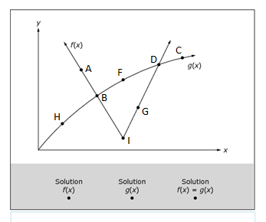7) The graphs of $y=f(x)$ and $y=g(x)$ are shown.

|  |  |
| --- | --- |
| Solutions for… | List **all** the points marked. |
| $$y=f\left(x\right)$$ |  |
| $$y=g(x)$$ |  |
| $$f\left(x\right)=g(x)$$ (solutions for both) |  |

8) Solve this system of equations. (Where do the graphs intersect?) $f\left(x\right)=x^{2}+5x-10; g\left(x\right)=x+2$

Honors Algebra 2 Name ________________________________________

Final Exam Review – Part 3

**THIS REVIEW IS PART OF YOUR EXAM GRADE**

**Unit 3: Quadratics**

1) Which of the following equations shows the minimum or maximum of h(x)? Is it a max or min?

h(x)=2(x+3)(x+1) h(x)=2(x+2)2-2 h(x)=2x2+8x+6

2) Factor to find the x-intercepts.

a) $x^{2}-13x+30$ =0 b) $x^{2}+5x-14=0$

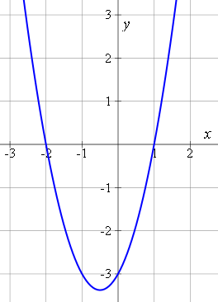3) **NC** The graph below can be represented by which of the following equations:

1. y = (x – 2)(x + 1)
2. y = (x – 1)(x + 2)
3. y = (x + 1)(x + 2)
4. y = (x – 1)(x – 2)

4) **NC** Select **all** of the functions that can represent the following graph:

1. 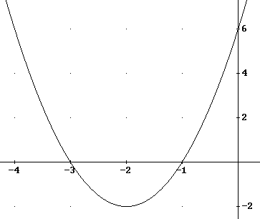f(x) = 2x2 + 4x + 3
2. f(x) = 2(x + 3)(x + 1)
3. f(x) = 2(x + 2)2 - 2
4. f(x) = 2(x – 3)(x – 1)
5. f(x) = 2x2 + 8x + 6
6. f(x) = 2(x – 2)2 – 2

5) **NC** Solve the following equations using any method.

a) b) c) =0

6) How many times does each of the following functions intersect the x-axis?

a) $y=3x^{2}+\frac{2}{3}x-\frac{1}{3}$ b) $f\left(x\right)=\frac{4}{3}x^{2}-4x+3$ c) $f\left(x\right)=2x^{2}-\frac{1}{2}x+\frac{3}{2}$

Honors Algebra 2 Name ________________________________________

Final Exam Review – Part 4

**THIS REVIEW IS PART OF YOUR EXAM GRADE**

**Unit 4: Rational/Radical**

1) **NC** Simplify: 2) **NC** Simplify:

3) **NC** Convert to radical form: $x^{\frac{4}{5}}$ 4) **NC** Convert to exponential form:

5) **NC**  Simplify. Write your answers in 6) Simplify: $x^{\frac{2}{3}}∙x^{\frac{3}{4}}$

simplest **radical form.**

a)

b)

7) **NC** Simplify: 8) **NC** Simplify:

9) **NC**  Solve: $\frac{4}{x}=\frac{-3}{x+8}$ 10) Simplify: $\frac{x^{2}+11x+30}{x^{2}+3x-18}$

Solve each equation. Remember to check for **extraneous solutions**.

11) =7 12) 13)