Honors Algebra 2 – Test Review Name __________________________

Transformations of Functions Date ________________ Hour ______

Graph each parent function. Fill in the parent function name and equation. Describe the transformation(s). Then graph the transformation.

1) f(x) = (x – 3)² + 5 2) f(x) = |x + 3| - 2

Parent function Parent function

Name: ____________ Name: ____________

Equation: __________ Equation: __________

Transformation: _______________________ Transformation: ______________________

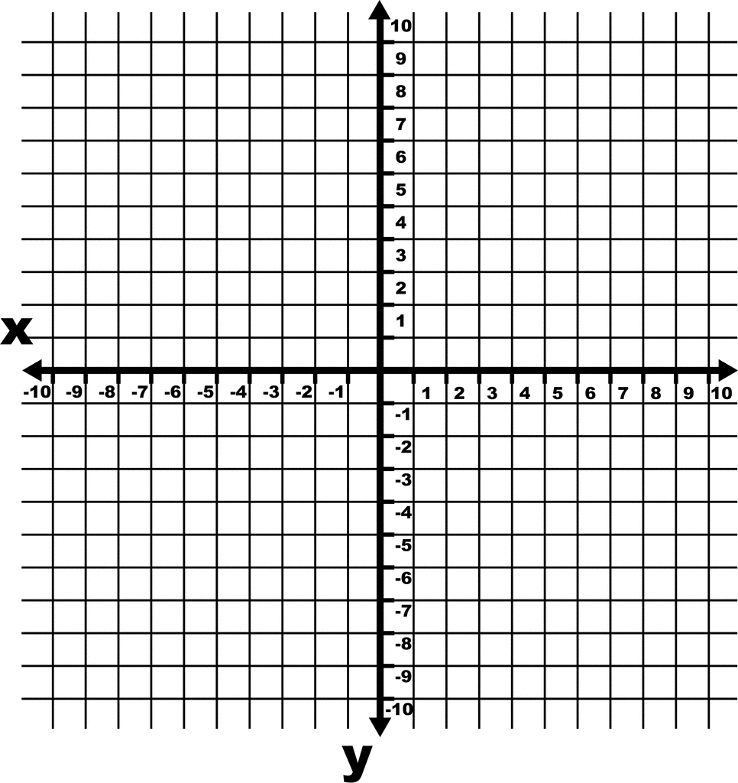 

3) f(x) = -2x²

Parent function

Name: ____________

Function: __________

Transformation: _________________________



Give the name and equation of the parent function and describe the transformation(s) represented by each equation.

4. Name and Equation ________________________________

Transformation(s) _________________________________

5. Name and Equation ________________________________

Transformation(s) _________________________________

6. Name and Equation ________________________________

Transformation(s) _________________________________

7.  **- 8** Name and Equation ________________________________

Transformation(s) _________________________________

8. Name and Equation ________________________________

Transformation(s) _________________________________

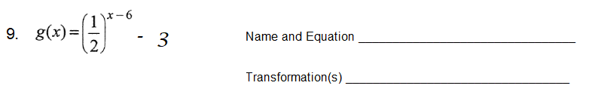

10. Name and Equation ________________________________

Transformation(s) _________________________________

11. Name and Equation ________________________________

Transformation(s) _________________________________