Honors Algebra 2 Name ___________________

Review 5.1-5.2 Date ___________ Hour ____

Determine whether each function is linear or quadratic. Identify the quadratic, linear, and constant terms.

1)*f*(*x*) = 3*x*2 – (4*x* – 8) 2. *y* = 3*x*(*x* –1) – (3*x +* 7) 3) *y =* 3*x*(*x +* 5)

Graph each function. Find the minimum or maximum of the quadratic function by graphing. Label these key features: the axis of symmetry, the vertex, 2 points on one side of the curve and their corresponding points (**5 points in all!.)**

4) *y =* 2*x*2 – 1 5) *y =* 2*x*2 + 4*x –* 3

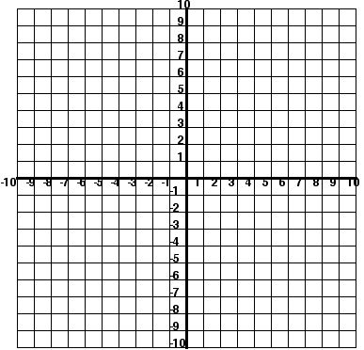 

6) A skating rink manager finds that revenue **R**based on an hourly fee **F** for skating is

represented by the function **R = -480 F² + 3210F.** What hourly fee will produce

maximum revenues?

7)

