Transformations of Functions Name ___________________________

Worksheet #6 Date _________________ Hour ______

Study the transformation on each graph. Then use the parent function and the transformation to write an equation for each graph.

1) 2) 3)

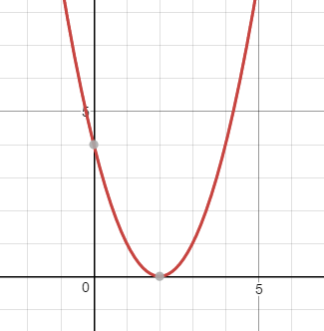 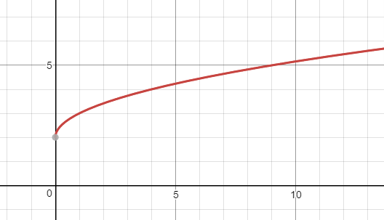 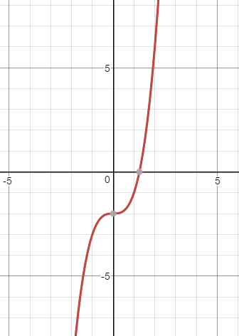

equation: ____________ equation: ____________ equation: ____________

4) 5) 6)

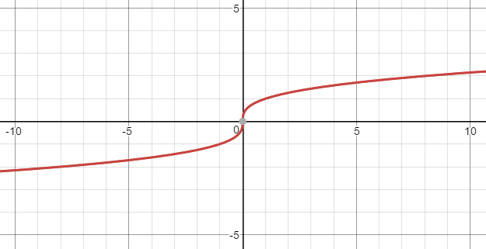 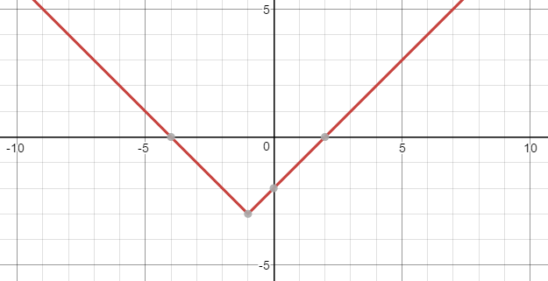 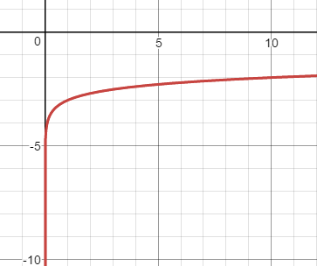

equation: ____________ equation: ____________ equation: ____________

7) 8) 9)

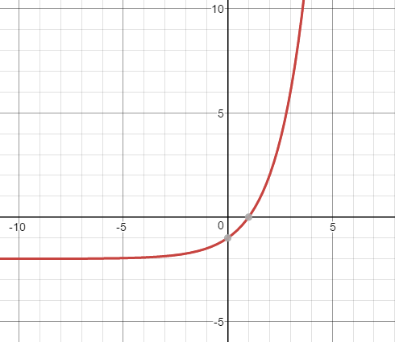 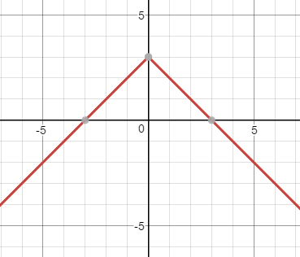 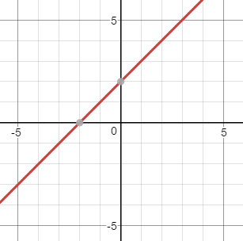

equation: ____________ equation: ____________ equation: ____________

10) 11) 12)

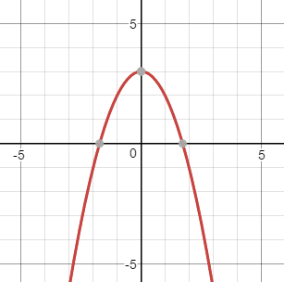 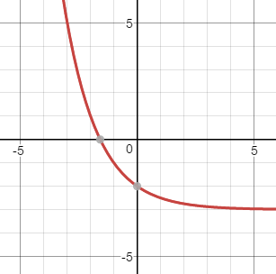 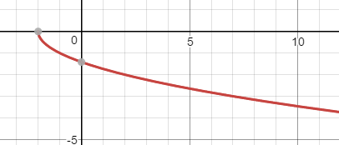

equation: ____________ equation: ____________ equation: ____________

Make up your own transformation examples. Draw the graph. Ask a partner to write the equation.

13) 14) 15)

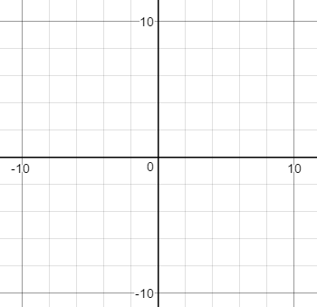  

equation: ____________ equation: ____________ equation: ____________