Transformations of Functions Name ___________________________

Worksheet #5 Date _________________ Hour ______

Give the name of the parent function and describe the transformation represented.

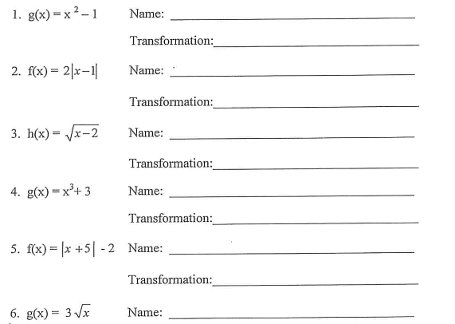

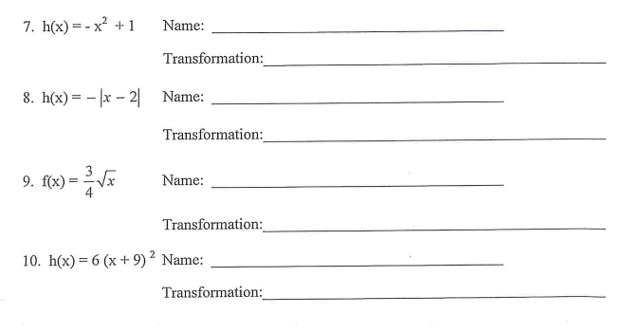

Give the name of the parent function and describe the transformation represented.

11. **f(x) = -3x** Name: _______________________________________________

Transformation: ________________________________________

12. **f(x) =**  Name: _______________________________________________

Transformation: ________________________________________

13. **f(x) = x + 5** Name: _______________________________________________

Transformation: ________________________________________

14. **f(x) = -log x + 2** Name: _______________________________________________

Transformation: ________________________________________

15**. $f\left(x\right)= \sqrt[3]{x-3}+5$**  Name: _______________________________________________

Transformation: ________________________________________

16. **f(x) =**  Name: _______________________________________________

Transformation: ________________________________________

17**. $f\left(x\right)= \sqrt[3]{x+1}-2$**  Name: _______________________________________________

Transformation: ________________________________________

18. **f(x) = 1/2 x - 6** Name: _______________________________________________

Transformation: ________________________________________

19. **f(x) = log(-x – 4)** Name: _______________________________________________

Transformation: ________________________________________

20. **f(x) = 1/3 (-x – 4)³ + 10**

Name: _______________________________________________

Transformation: ________________________________________