Transformations of Functions Name ___________________________

Worksheet #3 Date ______________ Hour _________

Graph the parent function and the transformation for each function below.

1)  2)  3)  4) 

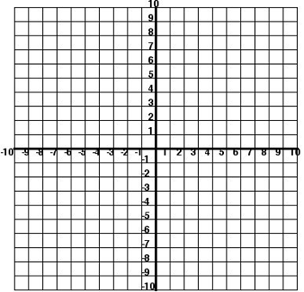 

5)  6)  7) f(x) = |x + 5| 8) f(x) = |x| + 5



9)  10)  11)  12) 



Compare each pair of functions from the same family. What do they have in common? What is the difference between the two transformations?

Given the parent function and a description of the transformation, write the equation of the transformed function, f(x).

13) Quadratic – vertical shift up 3 ____________

14) Linear – vertical shift down 7 ____________

15) Logarithmic – horizontal shift right 2 ____________

16) Exponential – vertical shift down 4 ____________

17) Absolute Value – vertical shift up 6 ____________

18) Absolute Value – vertical shift up 3, horizontal shift left 4 ____________

19) Logarithmic – horizontal shift right 2, vertical shift down 2 ____________

20) Exponential – vertical shift down 4, horizontal shift right 1 ____________

21) Quadratic – vertical shift up 3, horizontal shift left 4 ____________

22) Linear – vertical shift up 3