Family of Functions – Worksheet #3 Name ___________________________________

Increasing, Decreasing or Constant? Date _______________________ Hour ________

a. Fill in the increasing, decreasing and/or constant interval(s) for each relation. b. Then, fill in positive and/or negative intervals for each.

1) 2) 3)

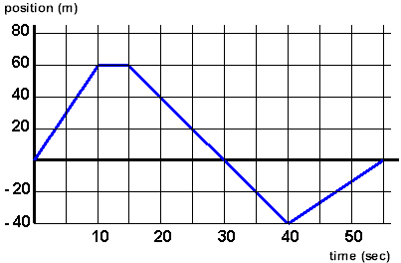 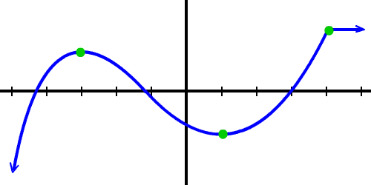 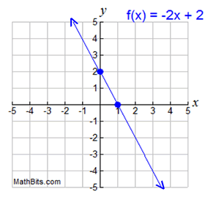

a. increasing _______________ a. increasing _________________ a. increasing _________________

decreasing ______________ decreasing ________________ decreasing ________________

constant ________________ constant __________________ constant __________________

b. positive _________________ b. positive ___________________ b. positive ___________________

negative ________________ negative __________________ negative __________________

4) 5) 6)

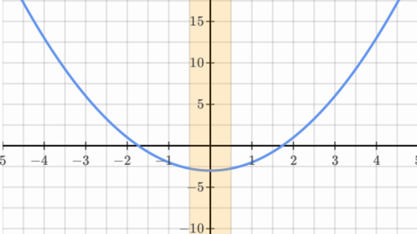 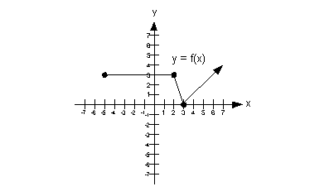 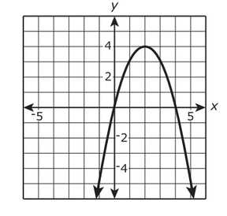

a. increasing _______________ a. increasing _________________ a. increasing _________________

decreasing ______________ decreasing ________________ decreasing ________________

constant ________________ constant __________________ constant __________________

b. positive _________________ b. positive ___________________ b. positive ___________________

negative ________________ negative __________________ negative __________________

7) 8) 9)

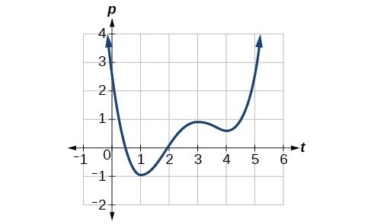 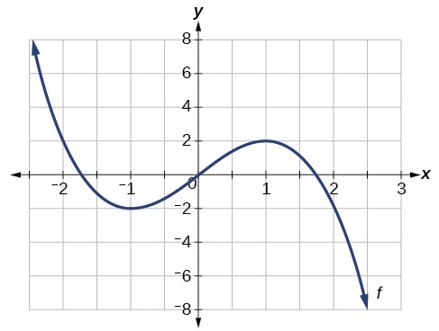 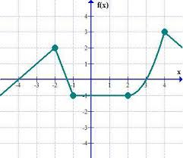

a. increasing _______________ a. increasing _________________ a. increasing _________________

decreasing ______________ decreasing ________________ decreasing ________________

constant ________________ constant __________________ constant __________________

b. positive _________________ b. positive ___________________ b. positive ___________________

negative ________________ negative __________________ negative __________________

10) 11) 12)

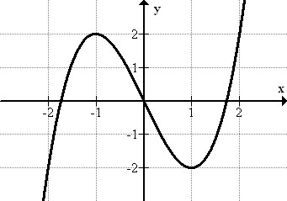 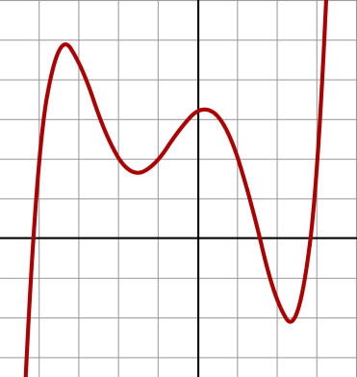 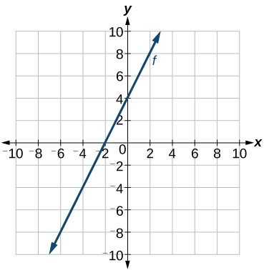

a. increasing _______________ a. increasing _________________ a. increasing _________________

decreasing ______________ decreasing ________________ decreasing ________________

constant ________________ constant __________________ constant __________________

b. positive _________________ b. positive ___________________ b. positive ___________________

negative ________________ negative __________________ negative __________________