Honors Algebra 2 Name _______________________

Solving Systems by Substitution and Elimination

Worksheet 2

**Solve each system of equations by substitution. Check by plugging in the numbers OR by**

**using another method to solve.**

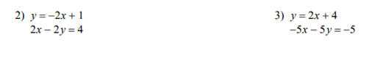







**Solve each system of equations by elimination. Check by plugging in the numbers OR by**

**using another method to solve.**







