SHAPES OF ALGEBRA 2
Day 2

Learning Target – I can graph functions.

Supplies: graph paper graphing calculator

Directions:
1. Follow the directions given to type your equations into the graphing calculator.
2. Carefully sketch the graphs of your equations onto the appropriate coordinate plane
(graph 1, graph 2, etc.) on your graph paper. Be sure to label the equation that goes
with each graph.
3. Compare your graphs to those of the other people at your table. When you are sure
you have the correct graph, trace over each of your graphs with the appropriate color.
(See below.)
4. Answer the questions for Day 2.

Graph 1 – Brown Equation: y = x²
Use the following key strokes:
Y =
X
GRAPH
X²

Graph 2 – Green Equation: $y=\sqrt{x}$

Use the following key strokes:
Y =
2nd
GRAPH
X
X²

Graph 3 – Purple Equation: $y={\text{10}}^{x}$ y = x² + 4

Use the following key strokes: 
Y =
10
GRAPH

Graph 4 – Blue Equation: y = log 10
Use the following key strokes:
Y =
Part 2
GRAPH
LOG
10

Graph 5 – Orange Equation: $y=x^{3}$
Use the following key strokes:
Y =
Ques 
X
3
GRAPH

Graph 6 – Red Equation: $y=\sqrt[3]{x}$
Use the following key strokes:
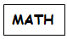
Y =
4
X
GRAPH

SHAPES OF ALGEBRA 2 - DAY 2

For each graph:
- Make sure you have written the equation below the graph.
- Highlight the intercepts (where the graph crosses the x- and y-axes). Write the coordinates of these points.

Questions: - Discuss these questions as a group. Then write out your answers below.

- How are your graphs similar to / different from those you sketched yesterday?

- For which graphs can you determine the maximum and/or minimum x – and y-values?
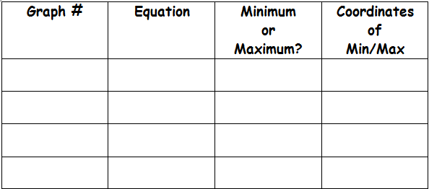

- Explain why some graphs have no minimum or maximum.
- Do you think any of today’s graphs are related in any way? Why or why not?
(HINT: Look at them in pairs.)

