Directions for Translation (Slide) Tessellation

Examples

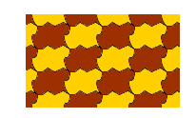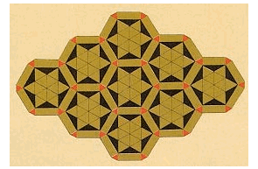

Use a square piece of paper.

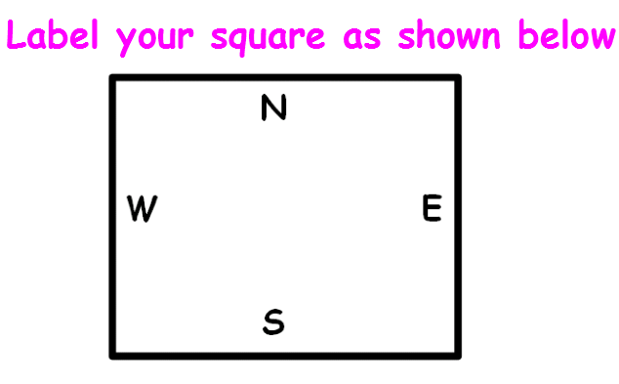

**From the top corner, draw a squiggley line to the other corner as shown below.** 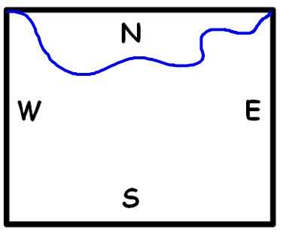

**Cut out this piece carefully. Make sure you cut into the corners as shown.**

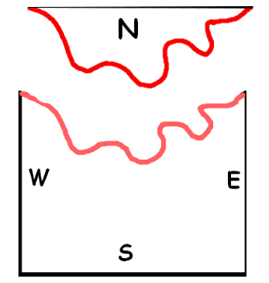

**Slide the piece to the south and tape it in place.**

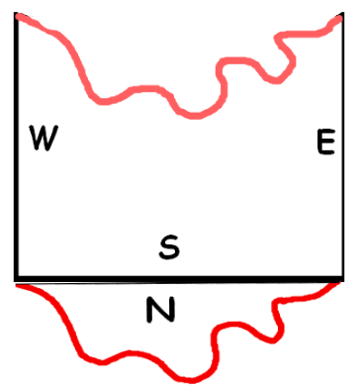

**Repeat the process, going from west to east. Cut the piece, slide it to the east and tape in place.**

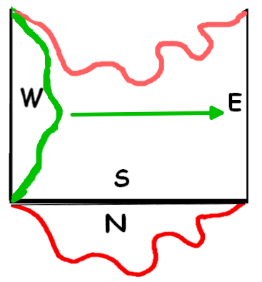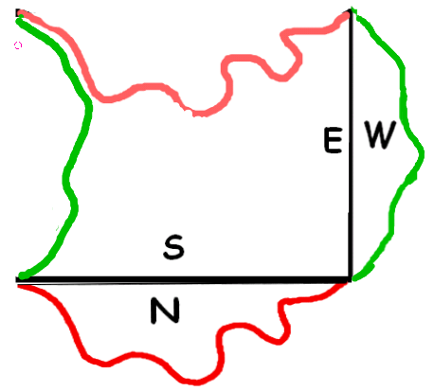

**Now trace your tessellation pattern piece in the middle of a piece of white paper, slide, and repeat.**

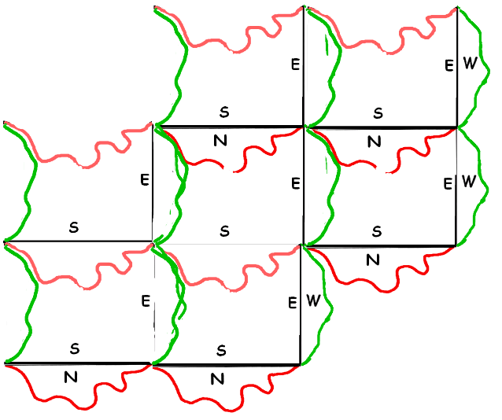

**Cover the entire paper.**