Day 2

Graph 1) Name _________________ Graph 2) Name ________________
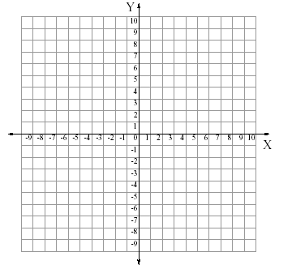
equation ________ equation ________

Graph 3) Name ______________ Graph 4) Name _________________

equation ________ equation ________

Graph 5) Name ______________ Graph 6) Name _________________

equation ________ equation ________

