Honors Algebra 2 – Final Exam Review - Part 1 Name _______________________

Polynomial Review

**This is part of your final exam grade.**

Simplify each expression.

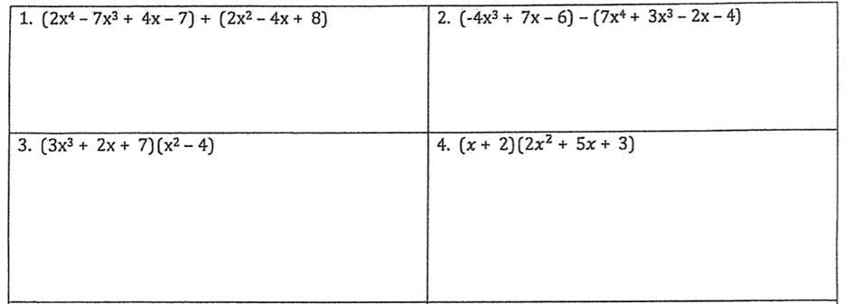

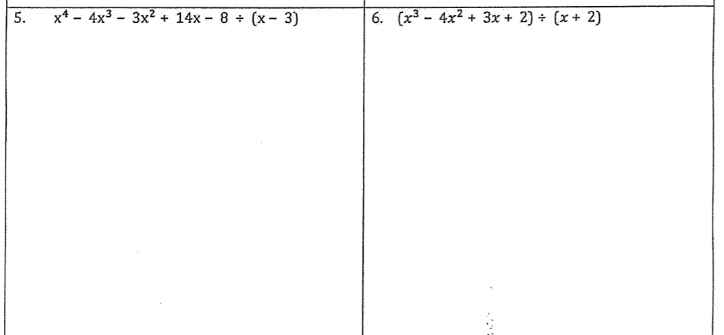

For #5 and 6, write your answer as quotient + remainder/divisor.





9. Write an expression to represent the area of the rectangle below.

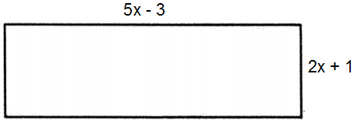

Honors Algebra 2 – Final Exam Review Name _______________________

Polynomial Review

**This is part of your final exam grade.**

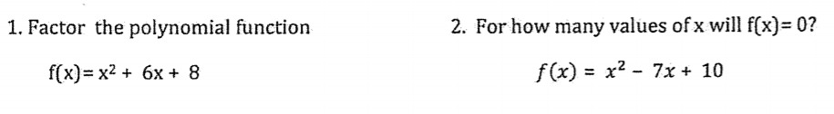



Factor each polynomial completely. Where does each cross the x-axis?

  

6. For the polynomial g(x), g(-5) = 0 and g(2) = 0. Write a function for g(x) in standard form.

Assume g(x) is quadratic.

7. Use the polynomial f(x) = x³ + 9x² + 6x – 56 to determine if the following are factors.

a) x – 4

b) x – 2

c) x + 7

d) x + 2

8. Use the polynomial f(x) = x³ + 6x² + x + 6 to determine if the following are factors.

a) x + 6

b) x – 1

c) x + 1

9. Factor and solve:

a) 8x³ - 1 = 0 b) x³ + 125 = 0

Honors Algebra 2 – Final Exam Review - Part 2 Name _______________________

Polynomial Review

**This is part of your final exam grade.**

**\*\*NO GRAPHING CALCULATOR SECTION\*\***

Write an equation in factored form for each graph.

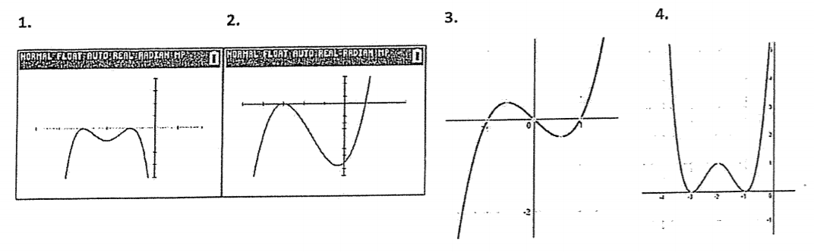

Write the letters of the graphs that have the same END BEHAVIOR as the following equations.

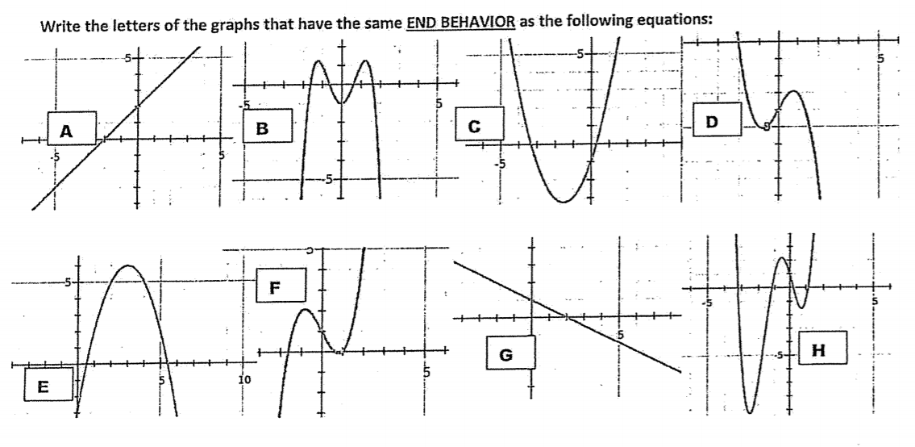

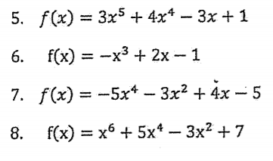

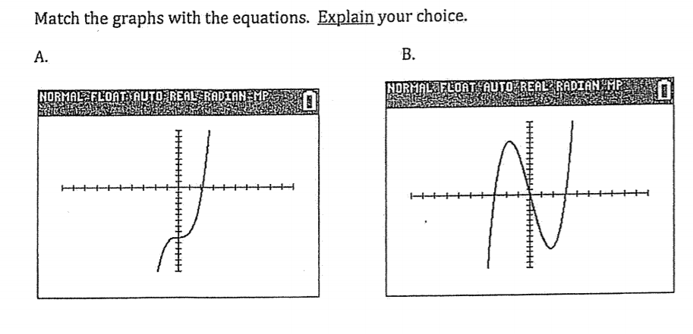 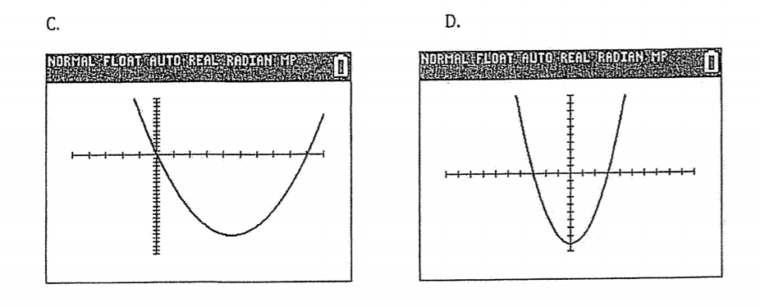 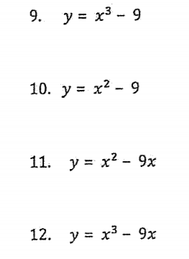

Honors Algebra 2 – Final Exam Review - Part 3 Name _______________________

Trig Review

**This is part of your final exam grade.**

1. a. Convert to degrees. (NC) b. Convert to radians. (NC)

310°

2. What is the degree measure of an angle whose measure is 14 radians? (NC)

Find the exact sine, cosine, and tangent of the angle. Show sketch and label triangle.

3) 4)

5) 90° 6)

7. Tan θ is -7/8 and sin is positive. Find the other two ratios and prove the identity (sin² + cos² = 1).

8. If sin θ = -5/11, what are all of the possible values for tan θ?

9. Graph one cycle of y = 7 sin θ. Make a table.

10. Graph one cycle of y = 2 cos π θ. Make a table.

11. Graph two cycles of y = -5 tan $\frac{π}{2}$ θ. Make a table.

Write an equation for each graph below.

12. 13.

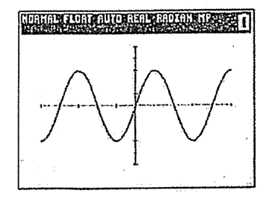 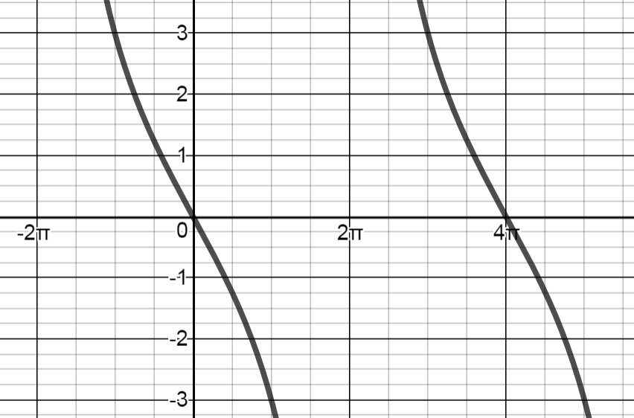

14. 15.

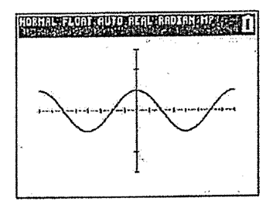 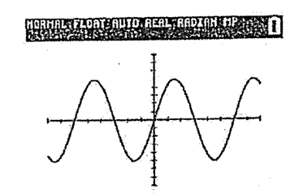

16. 17.

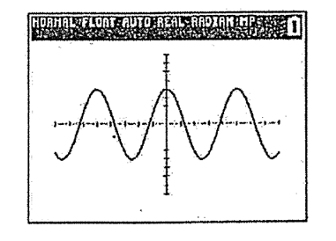 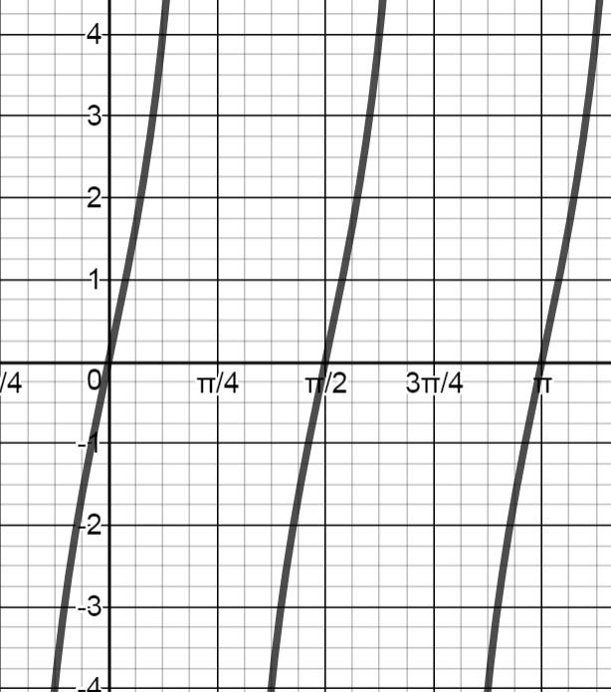

Honors Algebra 2 – Final Exam Review - Part 4 Name _______________________

Statistics

**This is part of your final exam grade.**

1. a) Find the mean, median, and IQR for each set of data below.

b) Predict which data will have a greater standard deviation. Then find the standard

deviation.

c) Which measures of central tendency and spread would you use for each set of data.

Explain your answer.

Set A Set B

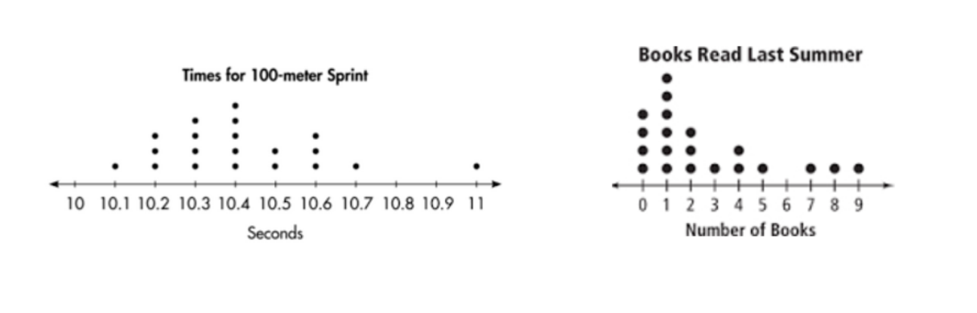

2. A fitness center offers two different yoga classes. The attendance for each class for 12 sessions is

represented in the box plots below.

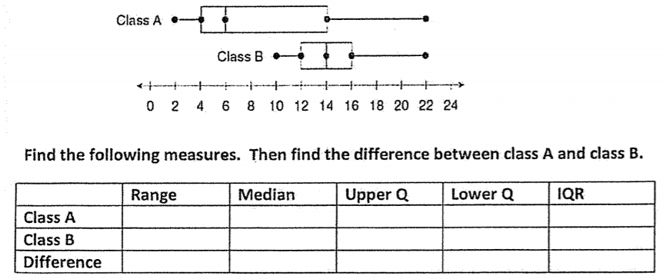

Which measure has the greatest difference? Which measure has the least difference?