Practice 4 – Statistics Name _______________________________

Measuring Variability for Skewed Distributions (IQR)

Lesson Summary

* The center of a skewed data distribution is described by the median.
* Variability of a skewed data distribution is described by the interquartile range (IQR).
* The IQR describes variability by specifying the length of the interval that contains the middle $50\%$ of the data values.
* Outliers in a data set are defined as those values more than $1.5$ (IQR) from the nearest quartile. Outliers are usually identified by an “*” or a “•” in a box plot.

Transportation officials collect data on flight delays (the number of minutes a flight takes off after its scheduled time). Consider the dot plot of the delay times in minutes for $60$ BigAir flights during December 2012:

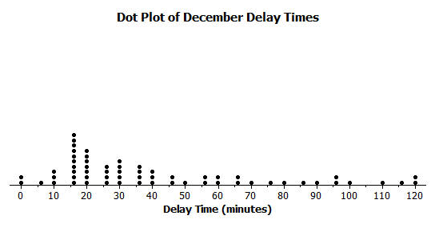

1. How many flights left more than $60$ minutes late?
2. Is this data distribution symmetrical or skewed?
3. Draw a box plot over the dot plot of the flights for December.
4. What is the interquartile range, or IQR, of this data set?
5. The mean of the $60$ flight delays is approximately $42$ minutes. Do you think that $42$ minutes is typical of the number of minutes a BigAir flight was delayed? Why or why not?
6. What percentage of flights with delays of more than $1$ hour. Were there many flight delays of more than $1$ hour?