Practice 3 – Statistics Name __________________________

Interpreting the Standard Deviation

Lesson Summary

* The mean and the standard deviation of a data set can be found directly using the statistical features of a calculator.
* The size of the standard deviation is related to the sizes of the deviations from the mean. Therefore, the standard deviation is minimized when all the numbers in the data set are the same and is maximized when the deviations from the mean are made as large as possible.

1. At a track meet, there are three men’s $100$ m races. The times for eight of the sprinters are recorded to the nearest $\frac{1}{10}$ of a second. The results of the three races for these eight sprinters are shown in the dot plots below.

Race 1

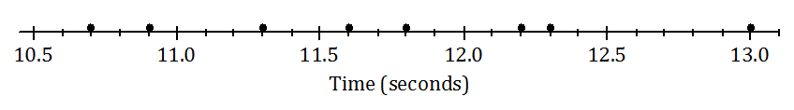

Race 2

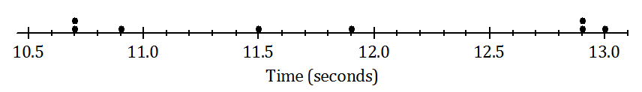

Race 3

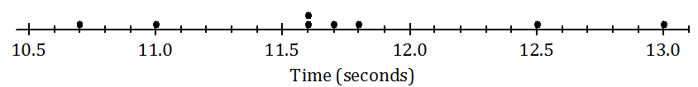

* 1. Remember that the size of the standard deviation is related to the sizes of the deviations from the mean. Without doing any calculations, indicate which of the three races has the smallest standard deviation of times. Justify your answer.
  2. Which race had the largest standard deviation of times? (Again, don’t do any calculations!) Justify your answer.
  3. Roughly what would be the standard deviation in Race 1? (Remember that the standard deviation is a typical deviation from the mean. So, here you are looking for a typical deviation from the mean, in seconds, for Race 1.)
  4. Use your calculator to find the mean and the standard deviation for each of the three races. Write your answers in the table below to the nearest thousandth.

|  |  |  |
| --- | --- | --- |
|  | Mean | Standard Deviation |
| Race 1 |  |  |
| Race 2 |  |  |
| Race 3 |  |  |

* 1. How close were your answers (a)–(c) to the actual values?