Practice – Statistics – Dot Plots, Mean, Median, Mode Name ____________________________

Consider the following three sets of data. Make a dot plot for each set of data. Then answer the following questions.

**Data Set 1: Pet owners**

Students from River City High School were randomly selected and asked, “How many pets do you currently own?” The results are recorded below.



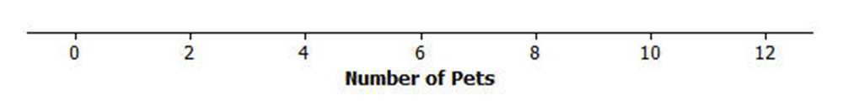

**Data Set 2: Length of the east hallway at River City High School**

Twenty students were selected to measure the length of the east hallway. Two marks were made on the hallway’s floor, one at the front of the hallway, and one at the end of the hallway. Each student was given a meter stick and asked to determine the length between the marks to the nearest tenth of a meter. The results are recorded below.



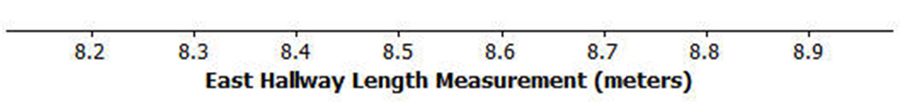

**DataData Set 3: Age of cars**

Twenty-five car owners were asked the age of their cars in years. The results are recorded below.



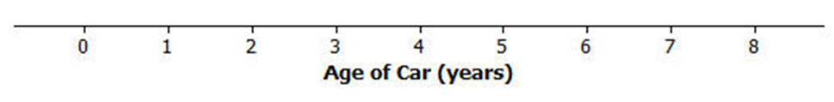

1. Calculate the mean number of pets owned by the thirty students from River City High School. Calculate the median number of pets owned by the thirty students.
2. What do you think is a typical number of pets for students from River City High School, the median or the mode? Explain why you made your choice.
3. Is the data skewed or symmetrical?
4. What is the mean length of the east hallway data set? What is the median length?
5. Is the data skewed or symmetrical?
6. A construction company will be installing a handrail along a wall from the beginning point to the ending point of the east hallway. The company asks you how long the handrail should be. What would you tell the company? Explain your answer.
7. Describe the distribution of the age of cars. Is it skewed or symmetrical?
8. What is the mean age of the twenty-five cars? What is the median age? Why are the mean and the median different?
9. What number would you use as an estimate of the typical age of a car for the twenty-five car owners, the mean or median? Explain your answer.

