Name Class Date
Practice 13-4 The Sine Function
Find the amplitude and period of each sine curve. Then write an equation for each curve.
1. 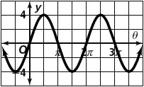 2. 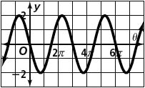

Sketch one cycle of each sine curve. Assume a > 0. Write an equation for each graph.
3. amplitude = 2; period = π 4. amplitude = 3; period = 2π

5. amplitude = 2; period = 6. amplitude = 2; period =

Sketch one cycle of the graph of each sine function.
13. y = 2 sin θ 14. y = −2 sin 4θ

16. y = 3 sin 17. y = −sin 2θ

