Honors Algebra 2 Name _______________________
Review – Sine and Cosine Date _______________ Hour ____

Write an equation for each graph.

1. 2.
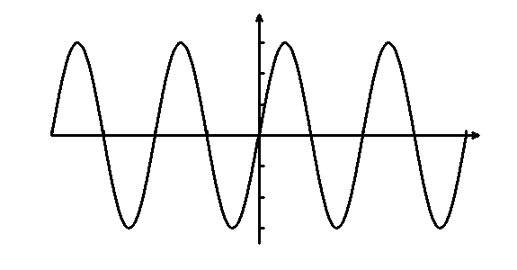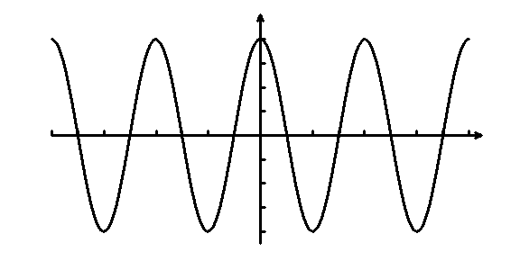
4
–4
4π
2π
–2π
–4π
3. 4.
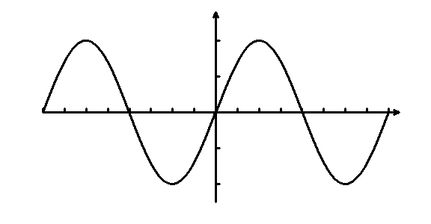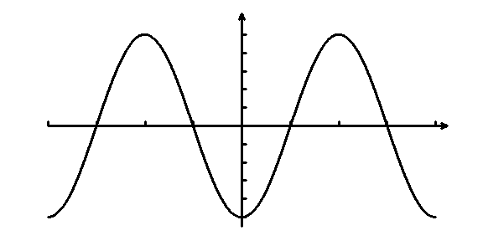
–2
2
4π
2π
–2π
–4π
5
–5
2π
π
–π
–2π

Sketch one cycle of each function.

5. y = 4 sin θ 6. y = 2 cos 2θ
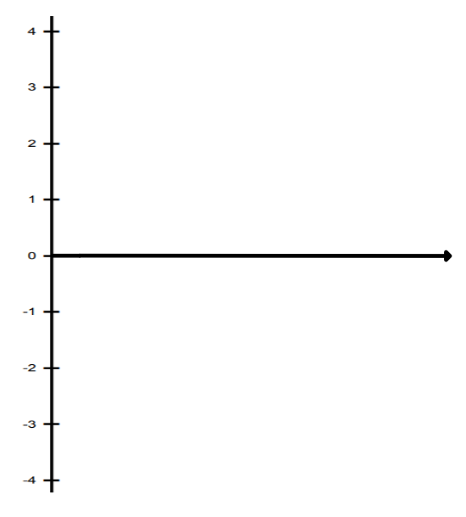
7. y = -3 cos π θ 8. y = – 2 sin 2θ

