Practice 1 – Statistics Name _______________________

Date ________________ Hour ___

Temperatures were recorded for 20 days during one month.

Average Temperature for 20 Days

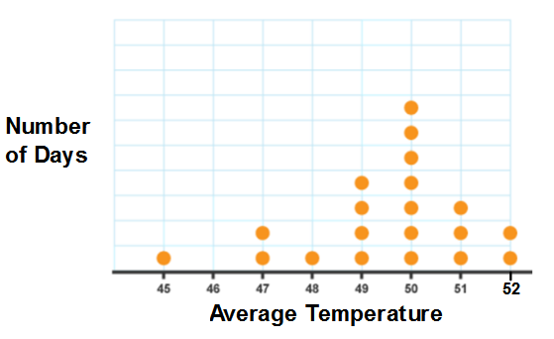

1. Find the mean, median, and mode for the data.

2. In which month do you think this data may have been collected? Why might this information be

important to know?

3. Would you describe this dot plot as representing a symmetric or a skewed data distribution?

Explain your answer.

The following histogram represents the age distribution of the population of the United States in 2010.

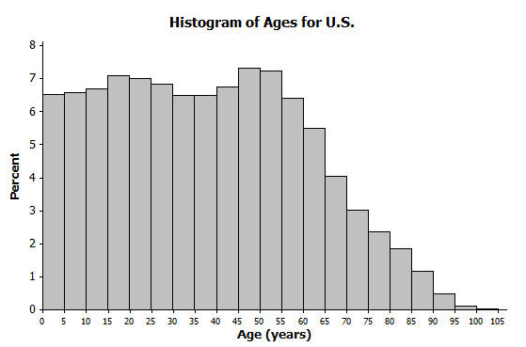

4. Approximately what percentage of people were between the ages of 50 and 60? Between

85 and 100?

5. Would you describe this dot plot as representing a symmetric or a skewed data distribution?

Explain your answer.

6. What do you think this graph is telling us about the population of the United States? Why

might we want to study the data represented by this graph?

The box plot below shows the number of sales for two salespeople in one month.

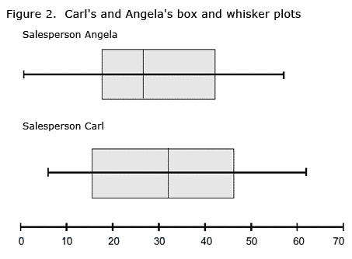

7. Approximate the median number of sales for each salesperson.

8. Which salesperson do you think would benefit from more training? Explain.