**13-6 Graphing the Tangent Function Name ____________________________**

Use your calculator to fill in the table below. Enter the angle measure in degrees to get the tangent value. Then graph the set of ordered pairs using the angle measure as ***x*** and the tangent as ***y***.

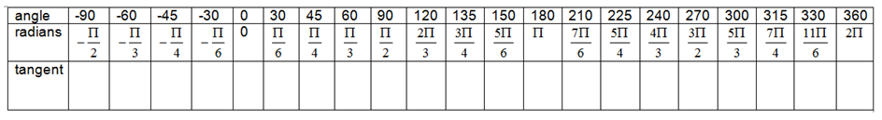

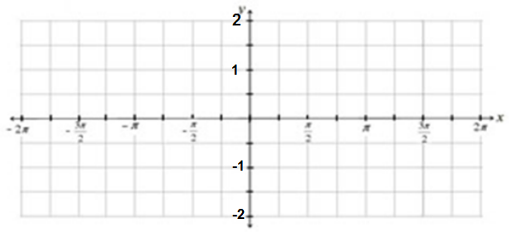

**13-6 Graphing the Tangent Function Name ____________________________**

Use your calculator to fill in the table below. Enter the angle measure in degrees to get the tangent value. Then graph the set of ordered pairs using the angle measure as ***x*** and the tangent as ***y***.



