Honors Algebra 2 Name _______________________________

Sine, Cosine and Tangent Date ________________ Hour ____________

Write the ratios for sin P and cos P.

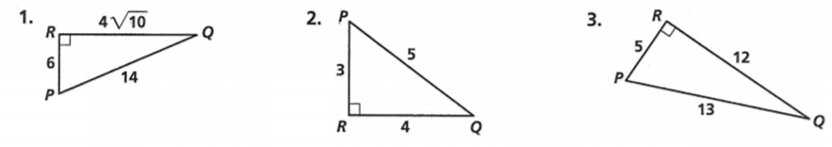

Find the value of x. Round lengths of segments to the nearest tenth.

4. 5. 6. 7.

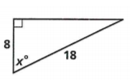 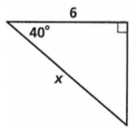 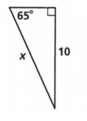 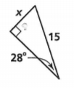

Write the ratios for tan E and tan F.

8. 9.

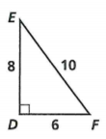 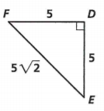

Find the value of x. Round lengths of segments to the nearest tenth.

10. 11.

