**Special Right Triangles Review Name ________________________________**

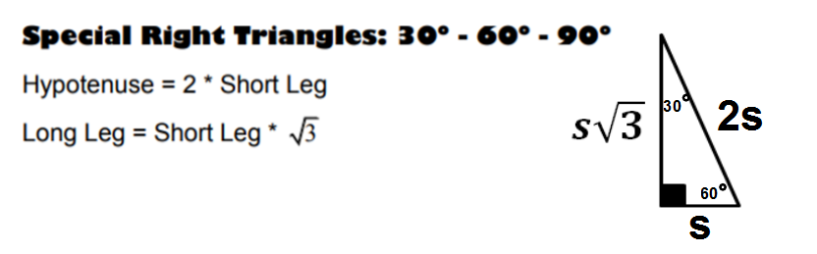

Find the missing values for each 30°-60°-90° triangle. Show your work!

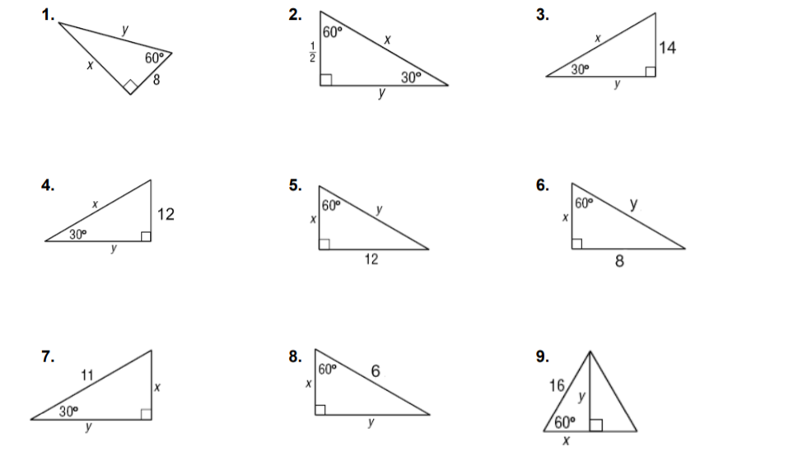

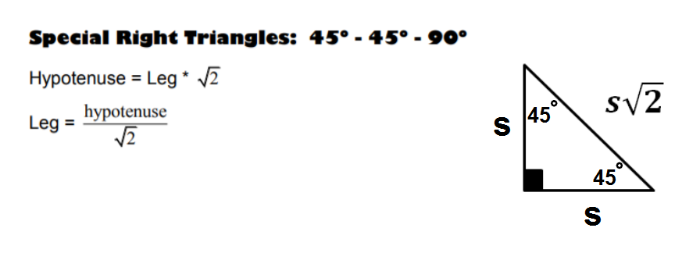

Find the missing values for each 45°-45°-90° triangle. Show your work!

