Function Families Chart Name _________________________

Function Families

Fill in the chart with the equation for each parent function and its graph.

Linear  Equation: __________  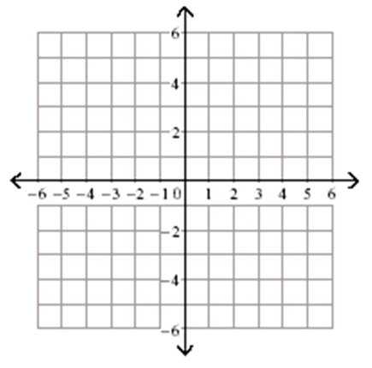 | Quadratic  Equation: __________ | Square Root  Equation: __________
Cubic  Equation: __________ | Cube Root  Equation: __________ | Absolute Value  Equation: __________

