Review for Test – Quadratics Name ____________________

Solve each quadratic equation using the method indicated. Check your solutions.

Solve each equation by taking square roots.

1) **n² + 4 = 40** 2) **k² + 196 = 0** 3) **x² - 2 = 17**

Solve each equation by factoring.

4) **8r² + 3r + 2 = 7r²** 5) **b² + b = 2** 6) **3x² - 8x – 16 = 0**

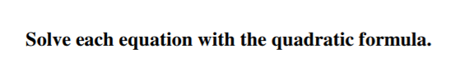



9) **x² - 2x + 21 = 0**

10) Solve by graphing. **3x² - 3x - 1 = 0** Sketch a picture of the graph and clearly label your

solutions.

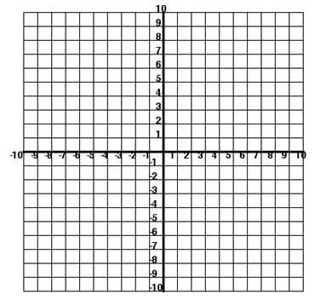

11) Convert this equation from standard form to vertex form.

**y = x² - 4x + 3**

Simplify each expression. Remember to write complex numbers in the form **a + bi**.

12)  13)  14) 

15)  16) **7i(-4i)** 17) **(3 + 4i)(9 – 2i)**

18) The height of a ball, in feet, after x seconds, can be modeled by the equation

**y = ** .

Define variables. x = y =

a) Draw a sketch of the graph. 

b) How long will it take to reach the max?

c) How high will the ball reach?

d) How long is the ball in the air?

e) Give a reasonable domain and range.