Honors Algebra 2 Name _____________________

Solving Systems of Equations by Graphing

Graph each set of equations by hand to solve. clearly indicate your solution. Then classify each

system as independent, dependent of inconsistent.

1)  2) 

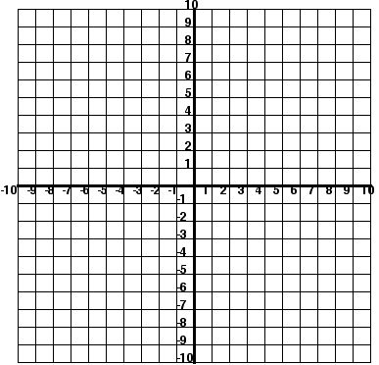 

3)  4) 

 

Solve using a graphing calculator.

11)  12) 

 

13)  14)  