Name Class Date
Practice 3-1 Graphing Systems of Equations
Classify each system without graphing. Explain your answer.
1. 2. 3.

4. 5. 6.

7. The spreadsheet below shows the monthly income and expenses for a new business.
a. Find a linear model for monthly income and a linear model for monthly expenses.
(Use 1, 2, 3, and 4 as indicated in the table for the months (x-values).)
b. Use the models to estimate the month in which income will equal expenses.
 | A | B | C
 | Month | Income | Expenses
1 | May | $1500 | $21,400
2 | June | $3500 | $18,800
3 | July | $5500 | $16,200
4 | August | $7500 | $13,600
Solve each system by graphing. Check your answers.
8. 9. 10.
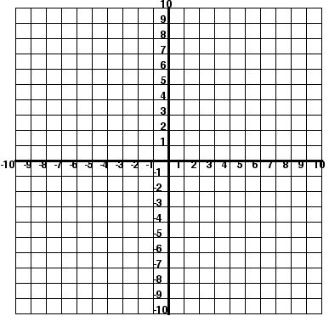

Name Class Date
Practice 3-2 Solving Systems Algebraically
Solve each system by elimination.
1. 2. 3.

4. 5. 6.

7. Suppose your drama club is planning a production that will cost $525 for the set and $150 per performance. A sold-out performance will bring in $325. Write an equation for the cost C and an equation for the income I for p sold-out performances. Find how many sold-out performances will make the cost equal to the income.

Solve each system by substitution. Check your answers.
8. 9. 10.

11. 12. 13.

14. Suppose you bought eight oranges and one grapefruit for a total of $4.60. Later that day, you bought six oranges and three grapefruits for a total of $4.80. Now you want to find the price of each orange and of each grapefruit. Write an equation for each purchase. Solve the system of equations.

