Honors Algebra 2 Name _________________________ Linear Regression Practice - 3 Date ________________ Hour _____

For each set of data, use the linear regression function on a graphing calculator to write a system of equations. Solve the system of equations by graphing. Explain what the x- and y- values of the solution represent for that situation.

1) The table shows the number of pairs of shoes sold by two new employees, Malak and Ali,

at Ikram’s shoe store. Find a linear model for each employee’s sales.

|  |  |  |  |  |  |
| --- | --- | --- | --- | --- | --- |
| **Week** | **1** | **2** | **3** | **4** | **5** |
| **Malak** | **50** | **55** | **63** | **67** | **71** |
| **Ali** | **40** | **47** | **56** | **62** | **67** |

Equation 1 (Malak): __________________________________________

Equation 2 (Ali): _______________________________________

Solution: ____________________________________

Explanation:

When will Malak’s and Ali’s sales be the same? __________________________________

How many sales will they have at that time? _____________________________________

2. The table below shows the annual consumption of two vegetables in the U.S.

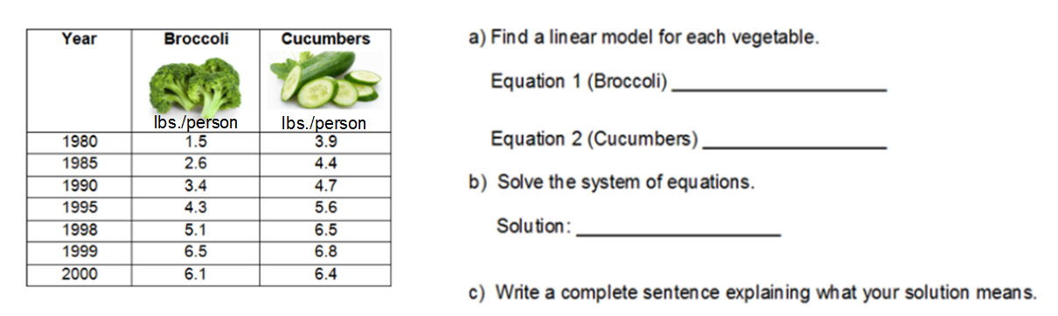

3. The table below shows the life expectancy at birth in the U.S in the years from 1970 to

2000.

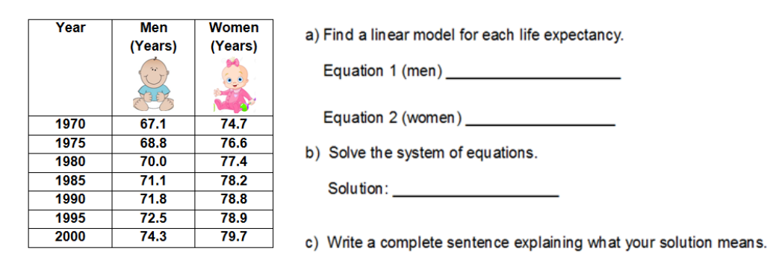

d) What do you think the life expectancy is now for men in the U.S.? For women? Justify

your answers.