Honors Algebra 2 – 3.4 Linear Programming Name ________________________

Date____________ Hour ________

Use linear programming to solve each problem. Use the following steps.

1) Define the variables.

2) Write the objective function and the constraints. Simplify the constraints if necessary.

3) Graph the constraints. Use a graphing calculator if necessary.

4) Find the coordinates of each vertex and evaluate the objective function for each one

(substitute each one into the objective function) to find the maximum or the minimum.

1. A calculator company produces a scientific calculator and a graphing calculator. Long-term

projections indicate an expected demand of at least 100 scientific and 80 graphing

calculators each day. Because of limitations on production capacity, no more

than 200 scientific and 170graphing calculators can be made daily. To satisfy a shipping

contract, a total of at least 200 calculators much be shipped each day.

If each scientific calculator sold results in a $2 loss, but each graphing calculator produces a $5 profit, how many of each type should be made daily to maximize net profits? What is the maximum profit?

x =

y =

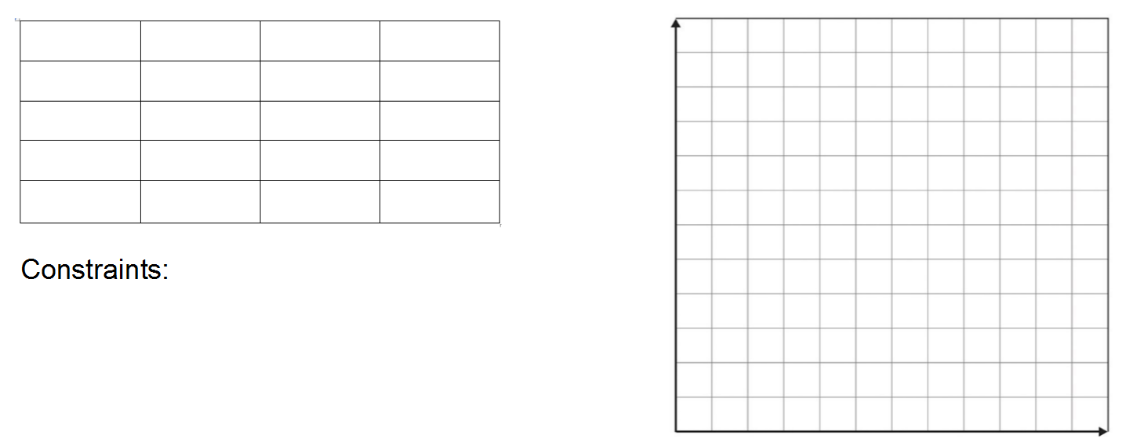

2. You need to buy some filing cabinets. You know that Cabinet X costs $10 per unit, requires

six square feet of floor space, and holds eight cubic feet of files. Cabinet Y costs $20 per

unit, requires eight square feet of floor space, and holds twelve cubic feet of files. You have

been given $140 for this purchase, though you don't have to spend that much. The office

has room for no more than 72 square feet of cabinets. How many of which model should

you buy, in order to maximize storage volume? What is the maximum volume?

x =

y =



3. Rena has an online jewelry shop where she sells earrings and necklaces. It takes 30 minutes

to make a pair of earrings and 1 hour to make a necklace. Since Rena is a math tutor, she only

has 10 hours a week to make jewelry.  In addition, she only has enough materials to make 15

total jewelry items per week.  She makes a profit of $15 on each pair of earrings and $20 on

each necklace.  **How many pairs of earrings and necklaces should Rena make each week**

**in order to maximize her profit, assuming she sells all her jewelry? What is the maximum profit?**

x =

y =

