Notes 1 – Transformations of Functions

Example 1 – Quick Check

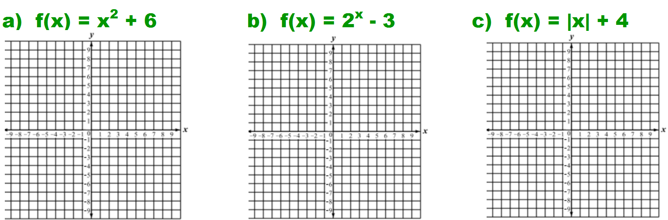

Notes 1 – Transformations of Functions

Example 1 – Quick Check



Notes 1 – Transformations of Functions

Example 1 – Quick Check

