Transformations of Functions Name ___________________________

Worksheet #5 Date _________________ Hour ______

Give the name of the parent function and describe the transformation represented.

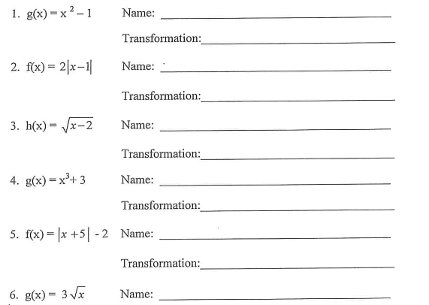

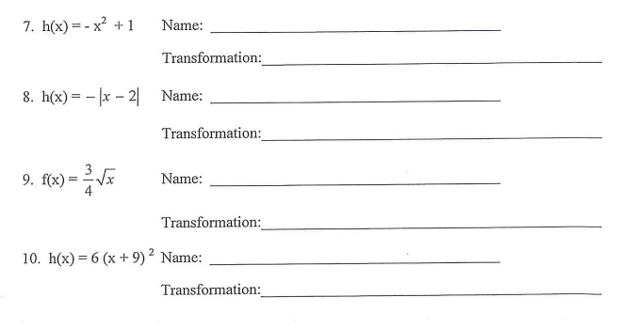

Give the name of the parent function and describe the transformation represented.

