Transformations of Functions Name ___________________________

Worksheet #4 Date _________________ Hour ______

Give the name of the parent function and describe the transformation represented. Then graph the transformation.

1) f(x) = -x + 4 2) f(x) = ½ x² - 5 3) f(x) = 3|-x + 2|

Name : ________________ Name : ________________ Name : ________________

Transformation Transformation Transformation

_______________________ _______________________ _____________________

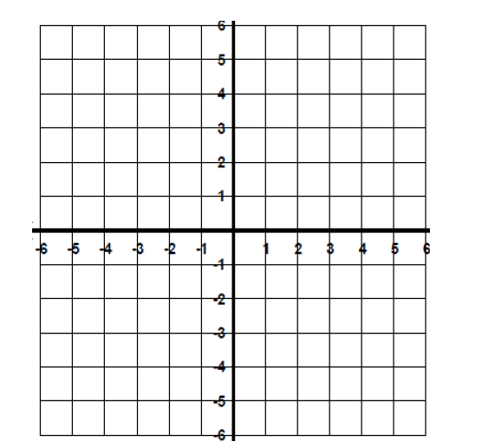

4) f(x) = -x³ 5) f(x) = - x² + 4 3) f(x) = -4|x| - 2

Name : ________________ Name : ________________ Name : ________________

Transformation Transformation Transformation

_______________________ _______________________ _____________________



Make up your own transformations. Describe them below. You must include functions from at least 3 of

the function families and include at least 2 transformations in each one.