Transformations of Functions Name ___________________________

Worksheet #3 Date ______________ Hour _________

Graph the parent function and the transformation for each function below.

1)  2)  3)  4) 

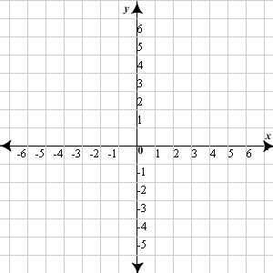   

5)  6)  7)  8) 

   

9)  10)  11)  12) 

   

Compare each pair of functions from the same family. What do they have in common? What is the difference between the two transformations?

Given the parent function and a description of the transformation, write the equation of the transformed function, f(x).

13) Quadratic – vertical shift up 3 ____________

14) Linear – vertical shift down 7 ____________

15) Logarithmic – horizontal shift right 2 ____________

16) Exponential – vertical shift down 4 ____________

17) Absolute Value – vertical shift up 6 ____________

18) Absolute Value – vertical shift up 3, horizontal shift left 4 ____________

19) Logarithmic – horizontal shift right 2, vertical shift down 2 ____________

20) Exponential – vertical shift down 4, horizontal shift right 1 ____________

21) Quadratic – vertical shift up 3, horizontal shift left 4 ____________

22) Linear – vertical shift up 3