Transformations of Functions Name _________________ Date _______

Worksheet #2

Give the name of the parent function and describe the transformation represented. Then graph both the parent function and the transformation.

1) f(x) = x² - 1 2) g(x) = |x – 1| 3) f(x) = 3x - 2

Parent: _______________ Parent: _________________ Parent: ____________

Transformation: Transformation: Transformation:

____________________ ______________________ __________________

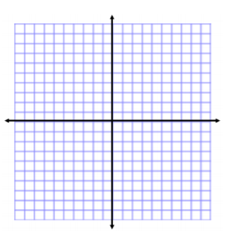  

4)  5)  6) g(x) = -2(x+1)² + 3

Parent: _______________ Parent: _________________ Parent: ____________

Transformation: Transformation: Transformation:

____________________ ______________________ __________________

  

Given the parent function and a description of the transformation, write the equation of the transformed function, f(x).

7) Absolute Value — vertical shift up 5 ____________________

8) Linear — vertical shift down 2 ____________________

9) Logarithmic — horizontal shift right 5 ____________________

10) Exponential — vertical shift up 8 ____________________

11) Quadratic — horizontal shift left 8 ____________________