Transformations Worksheet 10 Name ___________________

Write an equation for each graph by finding the value of **a.**

1) 2)

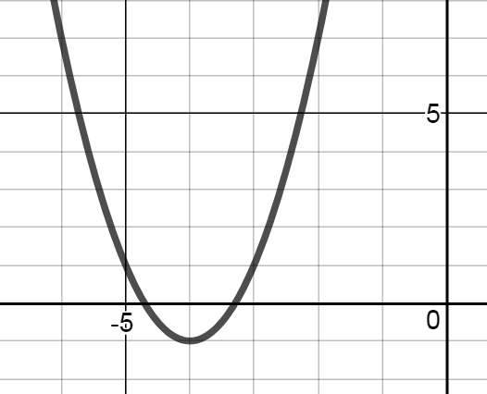 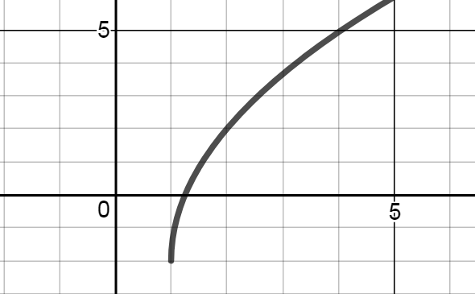

3) 4)

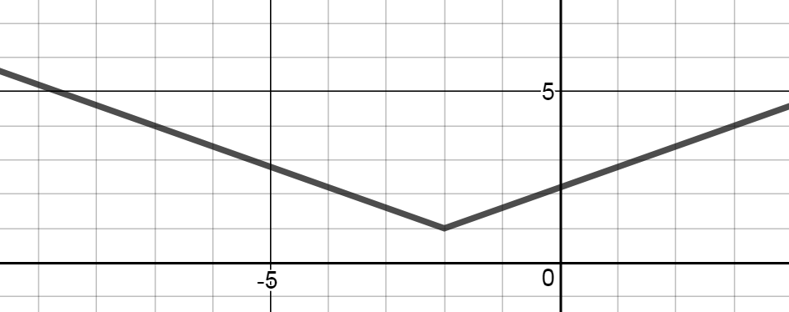 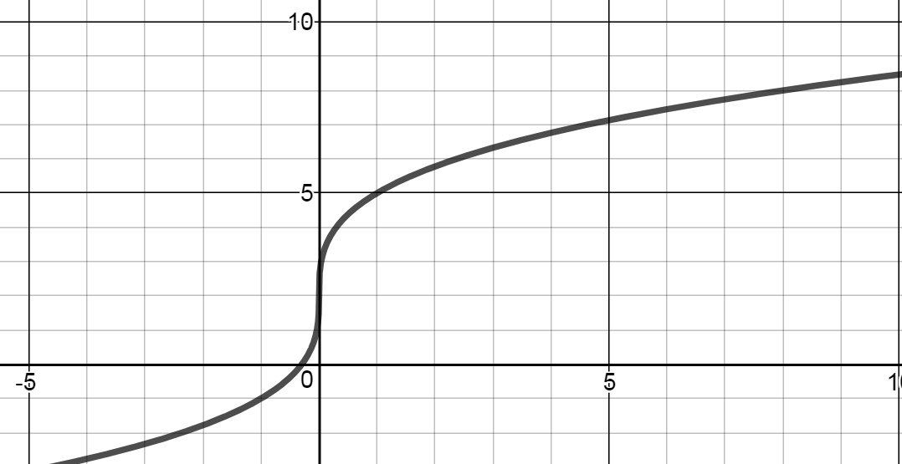

5) 6)

