Honors Algebra 2 Name ______________________

Linear Regression Practice 1 Date ______________ Hour ____

1. A convenience store manager notices that sales of soft drinks are higher on hotter days,

so he assembles the data in the table.

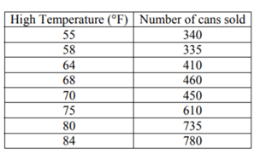

a) Find and graph a linear regression equation that models the data.

Follow the steps below.

**Directions for Linear Regression on the TI-84.**

1) Use these calculator keys: **STAT**, **EDIT** or **1**.

2) Enter the x-values in the **L1** column. Touch **ENTER** after entering each value.

3) Enter the y-values (the men’s times) in the **L2** column. Touch **ENTER** after entering each value

4) Use these calculator keys: **STAT**, right arrow key to **CALC,** then **4** for LinReg.

5) Use the **ENTER** key 5 times.

6) Write the equation - use the value for **a** as the coefficient of the x-term (the slope),

- use the value for **b** as the y-intercept

Write your equation here: ________________________________________

Sketch a graph of your equation below.

**Directions for sketching the graph for each equation on the TI-84.**

1) Put each equation into the **Y=** function.

2) Use the WINDOW key to change your graphing window as shown. Sketch a graph of each

equation. Label the axes and use an appropriate interval on each axis.

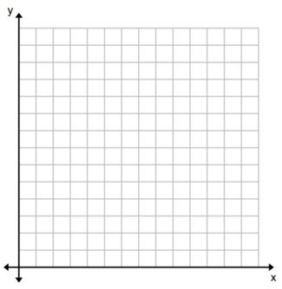

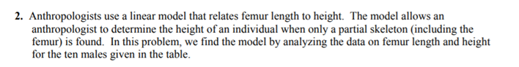

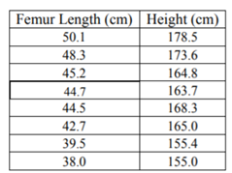

a) Find and graph a linear regression equation that models the data.

Write your equation here: ________________________________________

Sketch a graph of your equation below.

