Honors Algebra 2 Name _____________________

Test Review – Function Families – Part 1 Date _______________ Hour __

Sketch the parent function for each equation below. **Label at least two key points with coordinates.**

1) 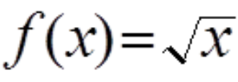 2) 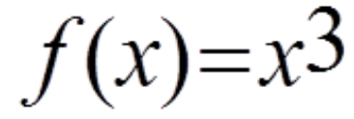 3) **f(x) = 2x**

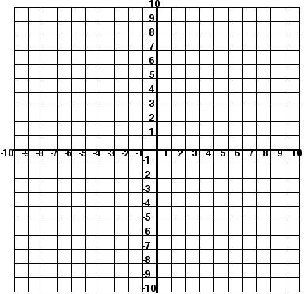  

4) **f(x) = x2** 5)  **f(x) = x** 6) **f(x) = (1/2)x**

  

Find the domain and the range for each function below.

7) 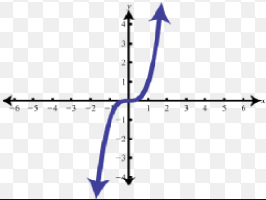 8) 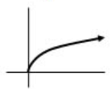 9) 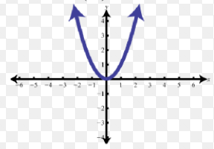

Domain: ________________ Domain: ________________ Domain: ________________

Range: _________________ Range: _________________ Range: _________________

Sketch the parent function for each equation below. **Label at least two key points with coordinates.**

10) **f(x) = |x|** 11) **f(x) = log x** 12) 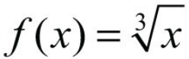

  

Identify the **increasing and/or decreasing** intervals of each function.

13) 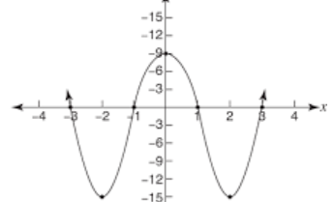 14) 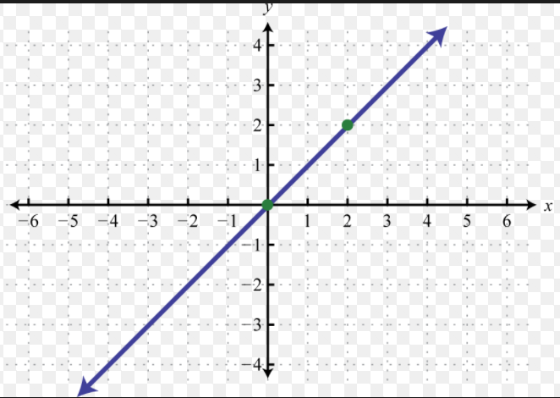

Identify the **positive and/or negative** intervals of each function.

15) 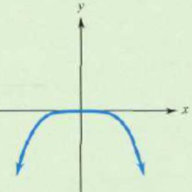 16) 