Name Class Date
Practice 2-1 Relations and Functions
For each function, find f(–2), ƒ , and f(3).
1. f(x) = 5x + 2 2. f(x) = x + 1

Use the vertical line test to determine whether each graph represents a function.
3. 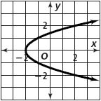 4. 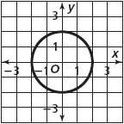 5. 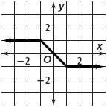
For each relation find the domain and range. Then explain whether the relation is a function
or not.
6. 7. {(−3, 5), (0, −2), (0, 4), (1, −2)}

8. {(−1, 2), (2, 2), (3, 2)} 9. {(0.5, −1), (0.5, 0). (0.5, 1), (0.5, 3)}

Explain whether each graph represents y as a function of x.
10. 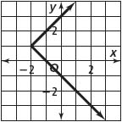 11. 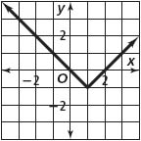 12. 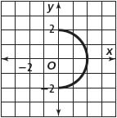
Make a mapping diagram for each relation, and determine whether it is a function.
13. {(1, 2), (2, 3), (2, 4), (3, 5)} 14. {(−1, 1), (0, 0), (1, 1), (2, 4), (3, 9)}
Suppose f(x) = –3x + 2 and g(x) = − 1. Find each value.
15. ƒ 16. 3g(4) 17.

