Honors Algebra 2 Name _____________________

Function Intervals Date ______________ Hour ___

Describe the intervals of each function below. Estimate the domain values if necessary.

1) 2)

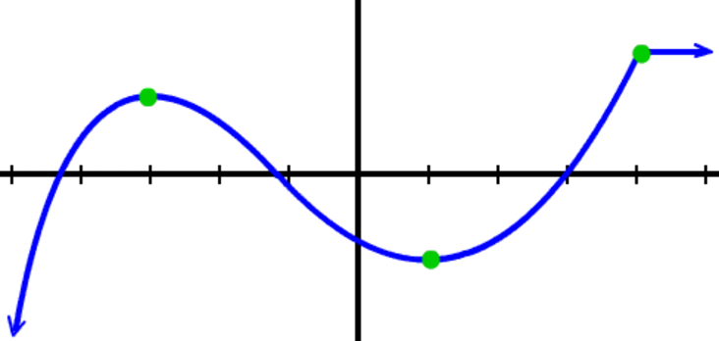 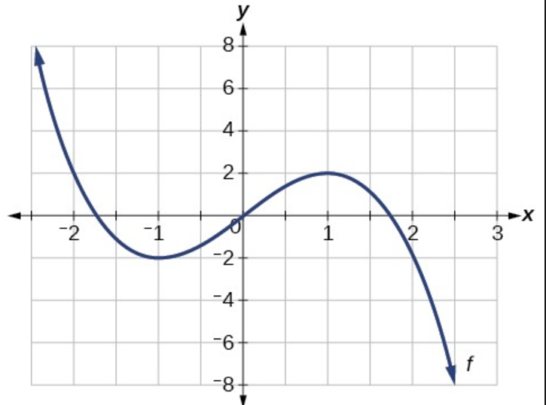

Increasing: _____________________ Increasing: _____________________

Decreasing: _____________________ Decreasing: _____________________

Constant: ______________________ Constant: _______________________

Positive: _______________________ Positive: ________________________

Negative: ______________________ Negative: _______________________

3) 4)

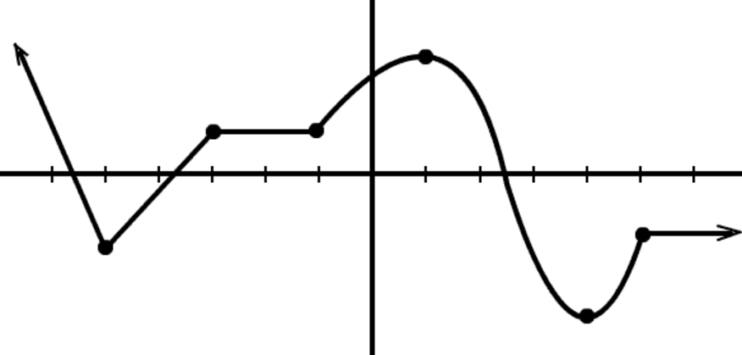 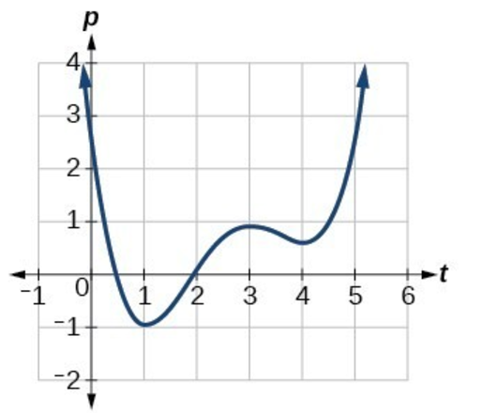

Increasing: _____________________ Increasing: _____________________

Decreasing: _____________________ Decreasing: _____________________

Constant: ______________________ Constant: _______________________

Positive: _______________________ Positive: ________________________

Negative: ______________________ Negative: _______________________

End Behavior Examples

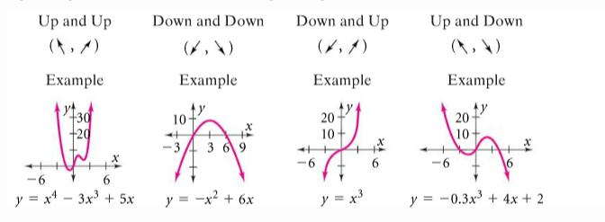

Describe the end behavior of each function. Use the arrows as shown in the above examples.

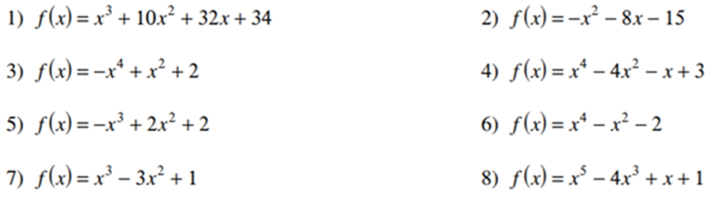

9) 10) 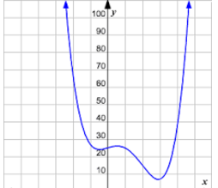 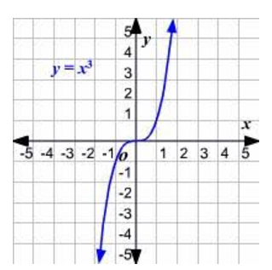

11) 12)

