f(x) = x
Domain
(interval)

Range
(interval)

Increasing
interval(s)

Decreasing
interval(s)

Positive
interval(s)

Negative
interval(s)

x-intercept(s)

y-intercept(s)

Does the graph go through the origin?
End behavior

Linear  f(x) = x  Table of Values  Choose two positive values, two negative values, and zero for x  x y | Sketch the graph of the function accurately and neatly. Use a ruler if necessary!  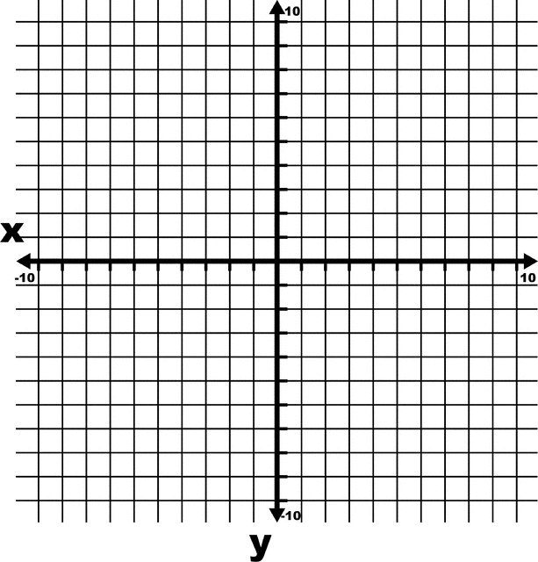

f(x) = |x|
Domain
(interval)

Range
(interval)

Increasing
interval(s)

Decreasing
interval(s)

Positive
interval(s)

Negative
interval(s)

x-intercept(s)

y-intercept(s)

Does the graph go through the origin?
End behavior

AbsoluteValue  f(x) = |x|  Table of Values  Choose two positive values, two negative values, and zero for x  x y | Sketch the graph of the function accurately and neatly. Use a ruler if necessary!
Domain
(interval)

Range
(interval)

Increasing
interval(s)

Decreasing
interval(s)

Positive
interval(s)

Negative
interval(s)

x-intercept(s)

y-intercept(s)

Does the graph go through the origin?
End behavior

Polynomial  (Quadratic)  f(x) = x²  Table of Values  Choose two positive values, two negative values, and zero for x  x y | Sketch the graph of the function accurately and neatly. Use a ruler if necessary!
Domain
(interval)

Range
(interval)

Increasing
interval(s)

Decreasing
interval(s)

Positive
interval(s)

Negative
interval(s)

x-intercept(s)

y-intercept(s)

Does the graph go through the origin?
End behavior

f(x) = x²
Domain
(interval)

Range
(interval)

Increasing
interval(s)

Decreasing
interval(s)

Positive
interval(s)

Negative
interval(s)

x-intercept(s)

y-intercept(s)

Does the graph go through the origin?
End behavior

Radical  (Square Root)  Table of Values  Use reasonable values for x  x y | Sketch the graph of the function accurately and neatly. Use a ruler if necessary!
Domain
(interval)

Range
(interval)

Increasing
interval(s)

Decreasing
interval(s)

Positive
interval(s)

Negative
interval(s)

x-intercept(s)

y-intercept(s)

Does the graph go through the origin?
End behavior

f(x) = $\sqrt{x}$
Domain
(interval)

Range
(interval)

Increasing
interval(s)

Decreasing
interval(s)

Positive
interval(s)

Negative
interval(s)

x-intercept(s)

y-intercept(s)

Does the graph go through the origin?
End behavior

Polynomial  (Cubic)  f(x) = x³  Table of Values  Choose two positive values, two negative values, and zero for x  x y | Sketch the graph of the function accurately and neatly. Use a ruler if necessary!
Domain
(interval)

Range
(interval)

Increasing
interval(s)

Decreasing
interval(s)

Positive
interval(s)

Negative
interval(s)

x-intercept(s)

y-intercept(s)

Does the graph go through the origin?
End behavior

f(x) = x³
Domain
(interval)

Range
(interval)

Increasing
interval(s)

Decreasing
interval(s)

Positive
interval(s)

Negative
interval(s)

Radical  (Cube Root)  Table of Values  Choose two positive values, two negative values, and zero for x  x y | Sketch the graph of the function accurately and neatly. Use a ruler if necessary!
Domain
(interval)

Range
(interval)

Increasing
interval(s)

Decreasing
interval(s)

Positive
interval(s)

Negative
interval(s)

x-intercept(s)

y-intercept(s)

Does the graph go through the origin?
End behavior

f(x) = $\sqrt[3]{x}$
Domain
(interval)

Range
(interval)

Increasing
interval(s)

Decreasing
interval(s)

Positive
interval(s)

Negative
interval(s)

x-intercept(s)

y-intercept(s)

Does the graph go through the origin?
End behavior

Exponential  Growth  f(x) = $2^{x}$  Table of Values  Choose two positive values, two negative values, and zero for x  x y | Sketch the graph of the function accurately and neatly. Use a ruler if necessary!
f(x) = $2^{x}$
Domain
(interval)

Range
(interval)

Increasing
interval(s)

Decreasing
interval(s)

Positive
interval(s)

Negative
interval(s)

x-intercept(s)

y-intercept(s)

Does the graph go through the origin?
End behavior

Logarithm  f(x) = logx  Table of Values  Use the values in the table for x  x y  100  10  1  0.1  0.01 | Sketch the graph of the function accurately and neatly. Use a ruler if necessary!
f(x) = logx
Domain
(interval)

Range
(interval)

Increasing
interval(s)

Decreasing
interval(s)

Positive
interval(s)

Negative
interval(s)

x-intercept(s)

y-intercept(s)

Does the graph go through the origin?
End behavior

Exponential  Decay  Table of Values  Choose two positive values, two negative values, and zero for x  x y | Sketch the graph of the function accurately and neatly. Use a ruler if necessary!
Domain
(interval)

Range
(interval)

Increasing
interval(s)

Decreasing
interval(s)

Positive
interval(s)

Negative
interval(s)

x-intercept(s)

y-intercept(s)

Does the graph go through the origin?
End behavior

