**Notes – Function Intervals**

Increasing and Decreasing Intervals

Example 1a Example 1b Example 1c Example 1d

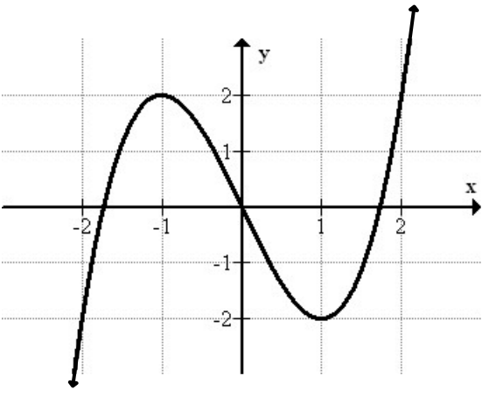 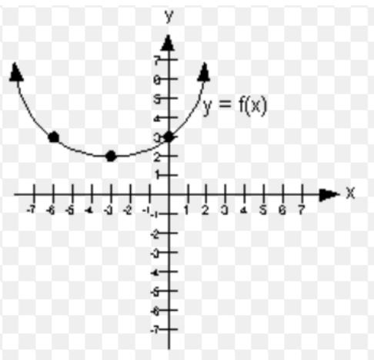 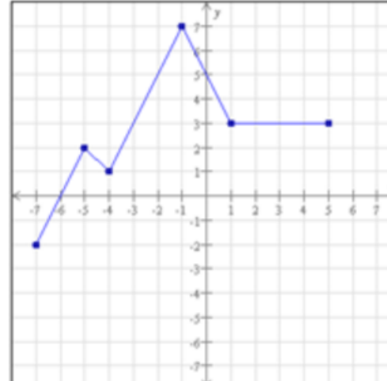 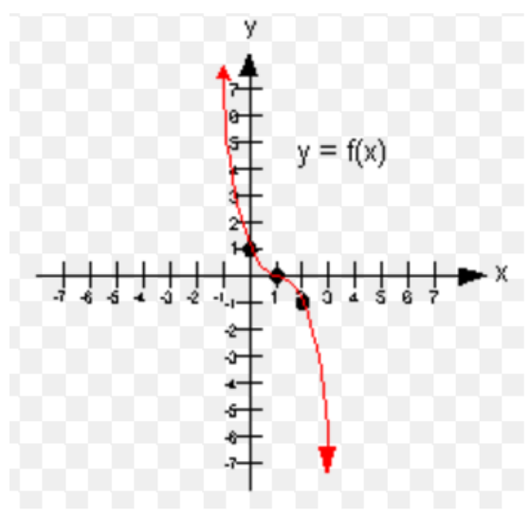

Positive and Negative Intervals

Example 2a Example 2b Example 2c Example 2d

   