Day 1 Graphs

Graph 1) Name _________________ Graph 2) Name ________________
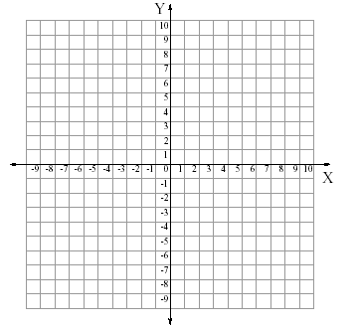
equation ________ equation ________

Graph 3) Name ______________ Graph 4) Name _________________

equation ________ equation ________

Day 1 Graphs

Graph 5) Name _________________ Graph 6) Name ________________
equation ________ equation ________

Graph 7) Name ______________ Graph 8) Name _________________

equation ________ equation ________

