Honors Algebra 2 – Final Exam Review - Part 1 Name _______________________

Polynomial Review

**This is part of your final exam grade.**

Simplify each expression.

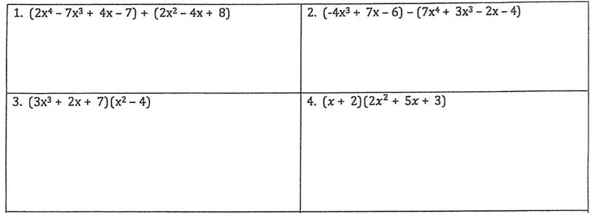

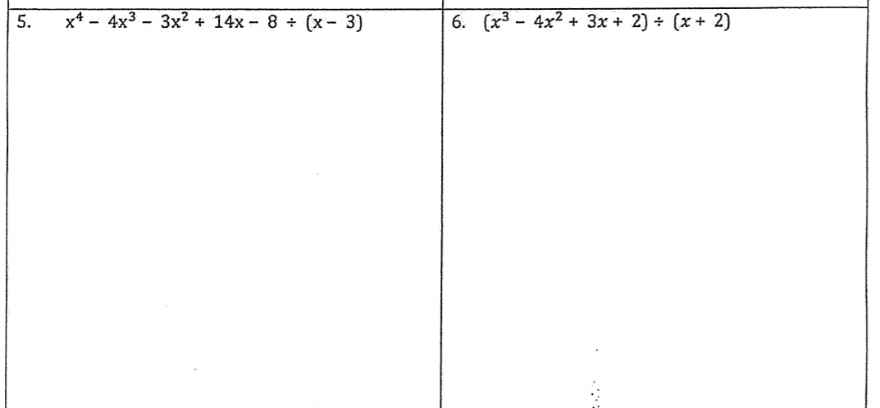

For #5 and 6, write your answer as quotient + remainder/divisor.





9. Write an expression to represent the area of the rectangle below.

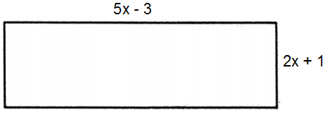

Honors Algebra 2 – Final Exam Review Name _______________________

Polynomial Review

**This is part of your final exam grade.**

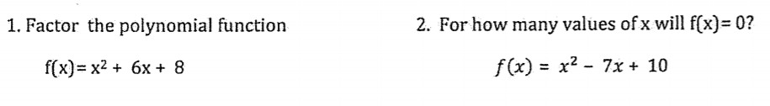



Factor each polynomial completely. Where does each cross the x-axis?

  

6. For the polynomial g(x), g(-5) = 0 and g(2) = 0. Write a function for g(x) in standard form.

Assume g(x) is quadratic.

7. Use the polynomial f(x) = x³ + 9x² + 6x – 56 to determine if the following are factors.

a) x – 4

b) x – 2

c) x + 7

d) x + 2

8. Use the polynomial f(x) = x³ + 6x² + x + 6 to determine if the following are factors.

a) x + 6

b) x – 1

c) x + 1

9. Factor and solve:

a) 8x³ - 1 = 0 b) x³ + 125 = 0

Honors Algebra 2 – Final Exam Review - Part 2 Name _______________________

Polynomial Review

**This is part of your final exam grade.**

**\*\*NO GRAPHING CALCULATOR SECTION\*\***

Write an equation in factored form for each graph.

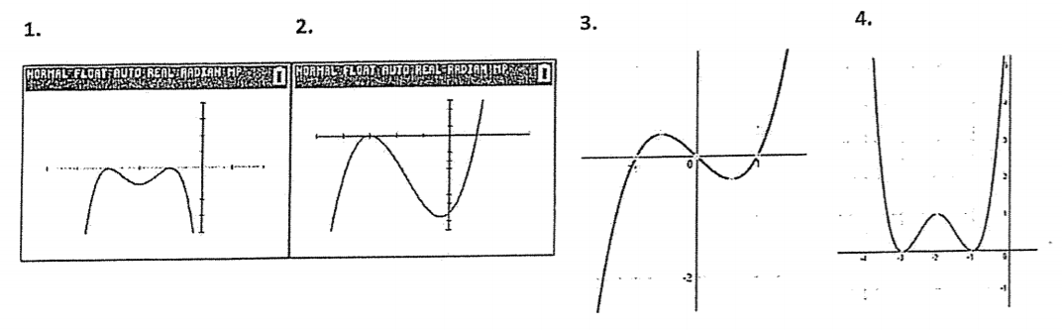

Write the letters of the graphs that have the same END BEHAVIOR as the following equations.

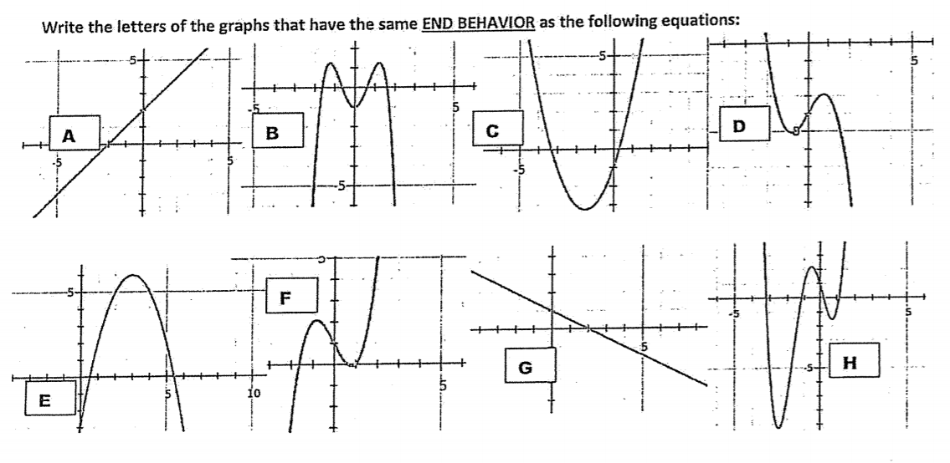

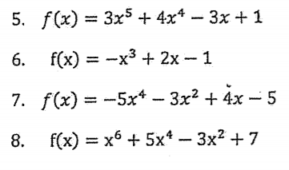

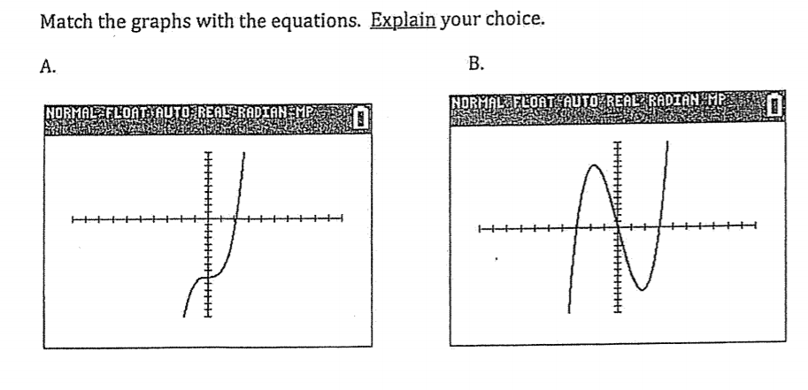 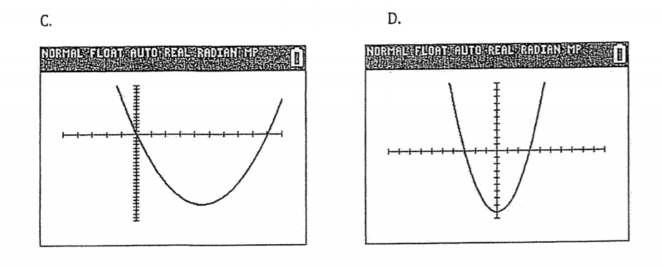 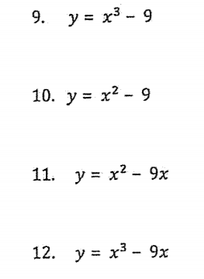

Honors Algebra 2 – Final Exam Review - Part 3 Name _______________________

Trig Review

**This is part of your final exam grade.**

1. a. Convert to degrees. (NC) b. Convert to radians. (NC)

310°

2. What is the degree measure of an angle whose measure is 14 radians? (NC)

Find the exact sine, cosine, and tangent of the angle. Show sketch and label triangle.

3) 4)

5) 90° 6)

7. Tan θ is -7/8 and sin is positive. Find the other two ratios and prove the identity (sin² + cos² = 1).

8. If sin θ = -5/11, what are all of the possible values for tan θ?

9. Graph one cycle of y = 7 sin θ. Make a table.

10. Graph one cycle of y = 2 cos π θ. Make a table.

11. Graph two cycles of y = -5 tan $\frac{π}{2}$ θ. Make a table.

Write an equation for each graph below.

12. 13.

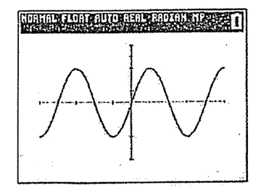 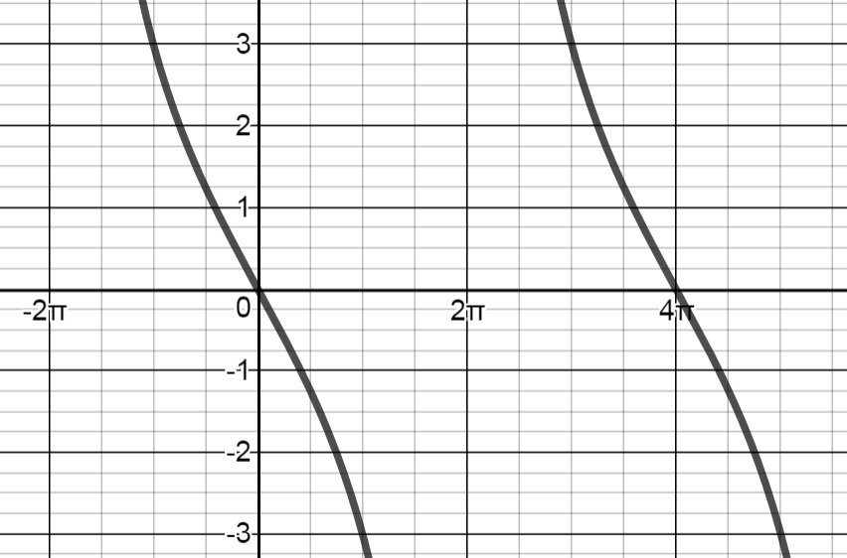

14. 15.

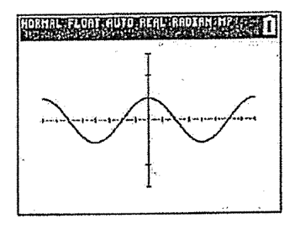 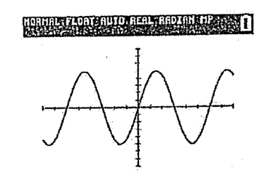

16. 17.

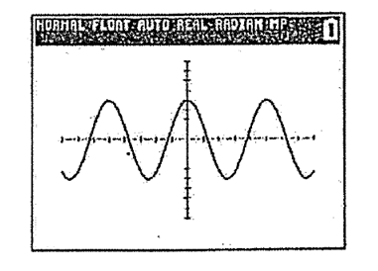 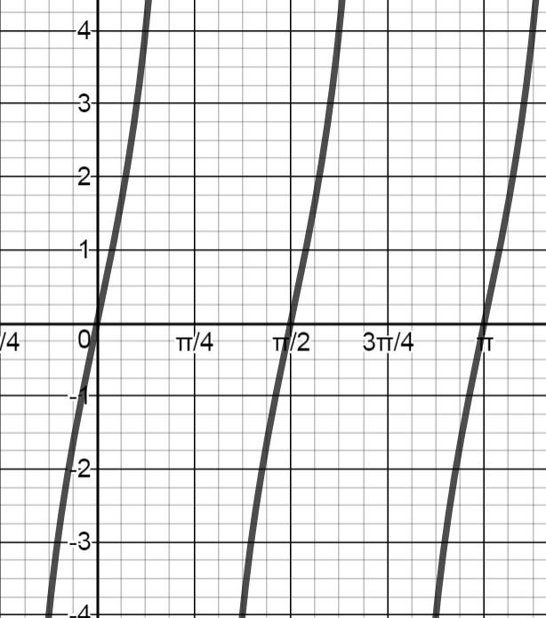

Honors Algebra 2 – Final Exam Review - Part 4 Name _______________________

Statistics

**This is part of your final exam grade.**

1. Find the mean and median for both sets of data below. Which do you think has a greater

standard deviation. Explain your answer.

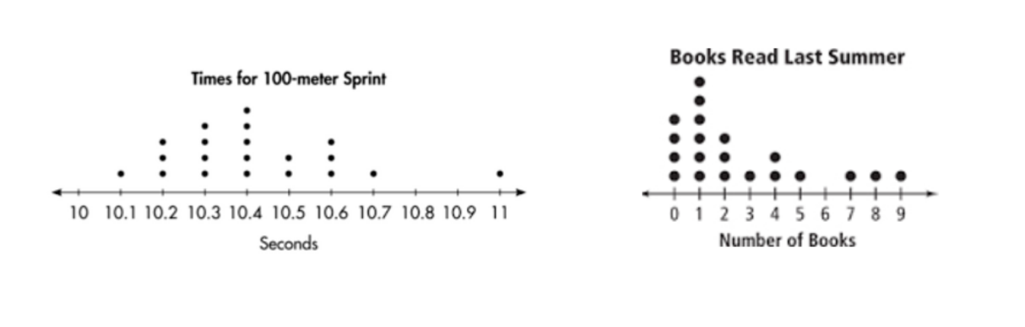

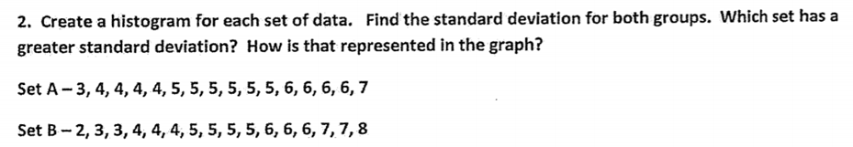

3. Which graph has the greatest standard deviation. Explain your answer.

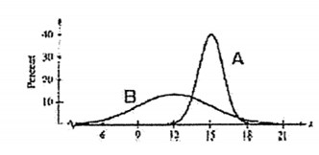

4. A fitness center offers two different yoga classes. the attendance for each class for 12 sessions is

represented in the box plots below.

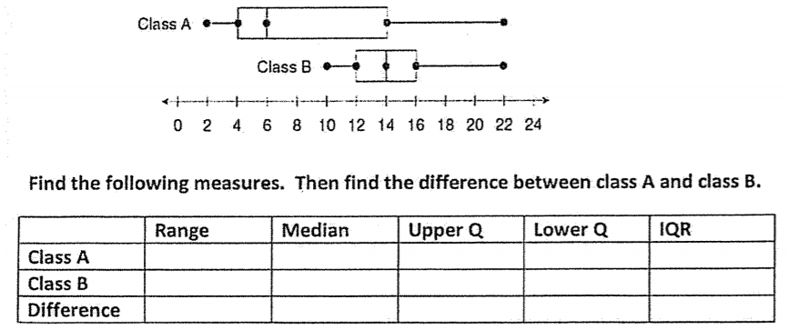

Which measure has the greatest difference? Which measure has the least difference?

5. Use the frequency (tally) table to answer the questions.

**Student Scores on a History Test**

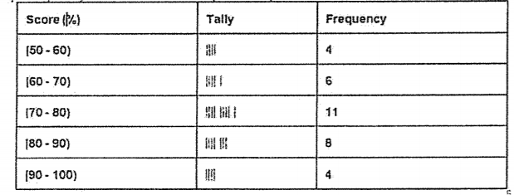

a) How many students took the test?

b) How many students scored between 70% and 80%?

c) What fraction of the students scored between 70% and 80%?

d) What fraction of the students scored between 70% and 100%?

e) If failing is below 60%, what fraction of the students did not pass the test?

**Effects of an outlier.** Circle the outlier in each set of data below. The calculate each measure without the outlier and with the outlier. Which measure of center (mean or median) or spread (standard deviation or IQR) is affected the most? The least?

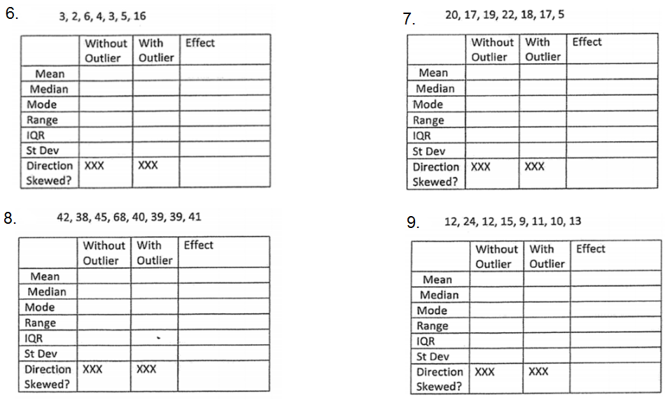

Use the given table to answer the questions.

|  |  |  |  |  |
| --- | --- | --- | --- | --- |
| Years of Experience | 0-4 | 5-9 | 10-14 | 14+ |
| Males | 12 | 6 | 17 | 21 |
| Females | 8 | 9 | 13 | 14 |

10. What is the probability of randomly selecting a female employee?

11. Given that the employee is male, what is the probability that they have less than 4 years of experience?

12. Given that the employee has between 10 and 14 years of experience, what is the probability that the employee is

female?

13. Given that the employee has more than 14 years of experience, what is the probability that the employee is male?

14. What is the probability of randomly selecting an employee with less than 14 years of experience who is female?