Honors Algebra 2

Round Table Review 13.4-13.6 – Graphing Sine, Cosine and Tangent

**USE YOUR OWN PAPER** to do the following problems. Then pass this paper to someone else in your group.

**Graph three cycles of each function. Show a table for each.**

1.  ***y* = 4 cos 2 θ** 2. ***y* = –2 sin 3 *θ***  3. **y = 3 tan ½ π *θ***

Honors Algebra 2

Round Table Review 13.4-13.6 – Graphing Sine, Cosine and Tangent

**USE YOUR OWN PAPER** to do the following problems. Then pass this paper to someone else in your group.

**Graph three cycles of each function. Show a table for each.**

1.  ***y* = 4 cos 2 θ** 2. ***y* = –2 sin 3 *θ***  3. **y = 3 tan ½ π *θ***

Honors Algebra 2

Round Table Review 13.4-13.6 – Graphing Sine, Cosine and Tangent

**USE YOUR OWN PAPER** to do the following problems. Then pass this paper to someone else in your group.

**Graph three cycles of each function. Show a table for each.**

1.  ***y* = 4 cos 2 θ** 2. ***y* = –2 sin 3 *θ***  3. **y = 3 tan ½ π *θ***

Honors Algebra 2

Round Table Review 13.4-13.6 – Graphing Sine, Cosine and Tangent

**USE YOUR OWN PAPER** to do the following problems. Then pass this paper to someone else in your group.

**Graph three cycles of each function. Show a table for each.**

1.  ***y* = 4 cos 2 θ** 2. ***y* = –2 sin 3 *θ***  3. **y = 3 tan ½ π *θ***

Honors Algebra 2

Round Table Review 13.4-13.6 – Writing Equations for Sine, Cosine and Tangent

**USE YOUR OWN PAPER** to do the following problems. Then pass this paper to someone else in your group.

Write an equation for each function.

1.

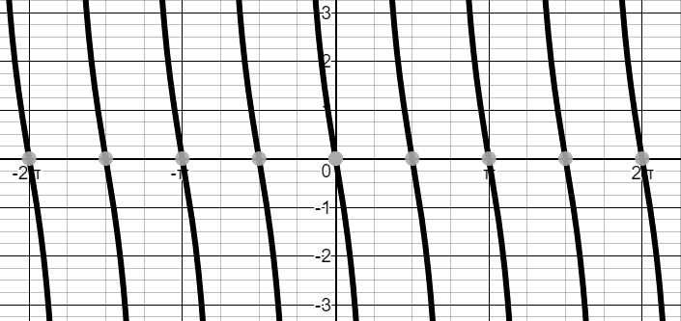

2.

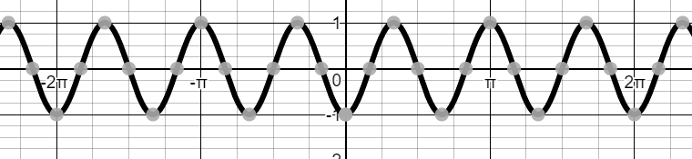

3.

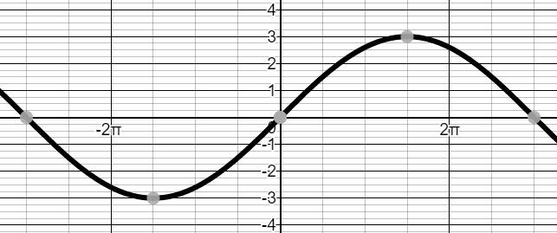

Honors Algebra 2

Round Table Review 13.2 – Finding Sine, Cosine and Tangent for an angle.

**USE YOUR OWN PAPER** to do the following problems. Then pass this paper to someone else in your group.

**Find the exact values of the cos, sin and tan of each angle. Draw the triangle (for #1, 2 and 3) and show all work including the ratios for each angle.**

1. **45°** 2. **−120°** 3. **150o** 4. **90o**

Honors Algebra 2

Round Table Review 13.2 – Finding Sine, Cosine and Tangent for an angle.

**USE YOUR OWN PAPER** to do the following problems. Then pass this paper to someone else in your group.

**Find the exact values of the cos, sin and tan of each angle. Draw the triangle (for #1, 2 and 3) and show all work including the ratios for each angle.**

1. **45°** 2. **−120°** 3. **150o** 4. **90o**

Honors Algebra 2

Round Table Review 13.2 – Finding Sine, Cosine and Tangent for an angle.

**USE YOUR OWN PAPER** to do the following problems. Then pass this paper to someone else in your group.

**Find the exact values of the cos, sin and tan of each angle. Draw the triangle (for #1, 2 and 3) and show all work including the ratios for each angle.**

1. **45°** 2. **−120°** 3. **150o** 4. **90o**

Honors Algebra 2

Round Table Review 13.1 – Cycles, Periods, and Amplitude

**USE YOUR OWN PAPER** to do the following problems. Then pass this paper to someone else in your group.

1. Write an equation of the cosine function with **amplitude 2** and period . Assume a < 0.

2. Write an equation for the graph of a sine curve with **amplitude 4** and **period** of  .

Assume *a* > 0.

3. Find the period and amplitude of the cosine function **y = 3 cos 8 θ**.

4. A particular sound wave can be graphed using the function **y = 3 sin 7 θ .**

Find the amplitude and period of the function.

Honors Algebra 2

Round Table Review 13.1 – Cycles, Periods, and Amplitude

**USE YOUR OWN PAPER** to do the following problems. Then pass this paper to someone else in your group.

1. Write an equation of the cosine function with **amplitude 2** and period . Assume a < 0

2. Write an equation for the graph of a sine curve with **amplitude 4** and **period** of  .

Assume *a* > 0.

3. Find the period and amplitude of the cosine function **y = 3 cos 8 θ**.

4. A particular sound wave can be graphed using the function **y = 3 sin 7 θ .**

Find the amplitude and period of the function.