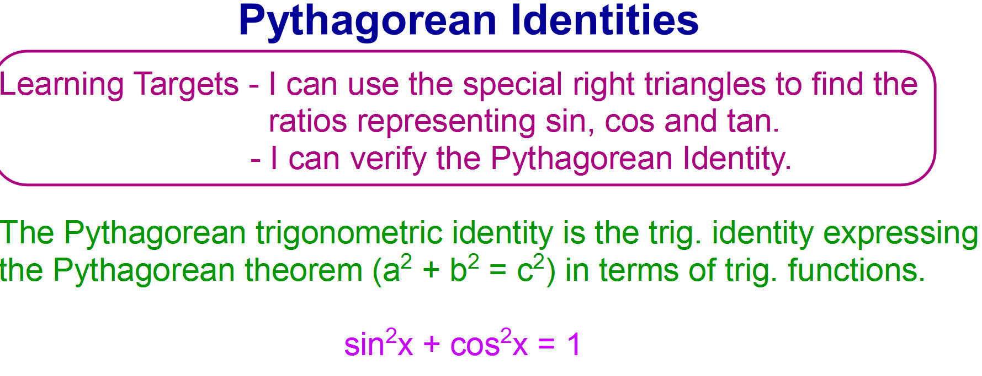

To find sin, cos, or tan using the special right triangles:

1. Draw the special right triangle in the correct quadrant according

to the numbers (positive/negative) in the given ratio.

2. Label the sides using the given ratio.

3. Use the Pythagorean Theorem to get the missing side.

4. Find the other trig ratios.

5. Verify the identity using the sin and cos ratios: sin2 + cos2 = 1

Example 1

Given sin θ = -2/5 in quadrant 3, find cos θ and tan θ. Then verify

the identity.

Example 2

Given tan θ = -5 in quadrant 2, find sin θ and cos θ. Then verify

the identity.

Example 3

Given cos θ = 3/5 in quadrant 1, find sin θ and tan θ. Then verify

the identity.