Notes 4 – Statistics Name _______________________

Interpreting the Standard Deviation

Learning Targets -

To find the mean and the standard deviation for a set of data, there are two ways you can use the calculator.

Method 1:

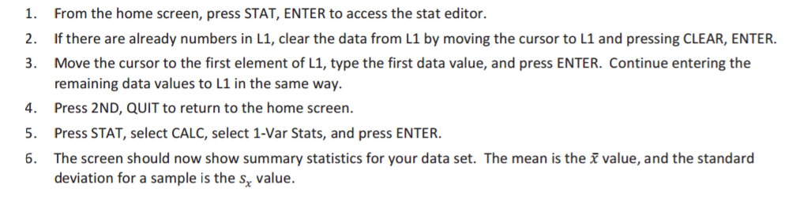

Method 2:

1. Press STAT, ENTER to enter the data. Indput the data.
2. Press 2ND, LIST.
3. Use the right arrow key to get to the MATH menu.
4. Choose option 3 for the mean or option 7 for standard deviation.

Exercise 1

1. The heights (in inches) of nine women are as shown below.

$$68.4 70.9 67.4 67.7 67.1 69.2 66.0 70.3 67.6$$

Use the statistical features of your calculator or computer software to find the mean and the standard deviation of these heights to the nearest hundredth.

Mean: ____________________

Standard Deviation: ____________________

Exploratory Challenge/Exercises 2–5

1. A group of people attended a talk at a conference. At the end of the talk, ten of the attendees were given a questionnaire that consisted of four questions. The questions were optional, so it was possible that some attendees might answer none of the questions, while others might answer $1$, $2$, $3$,or all $4$ of the questions (so, the possible numbers of questions answered are $0$, $1$, $2$, $3$, and $4$).

Suppose that the numbers of questions answered by each of the ten people were as shown in the dot plot below.

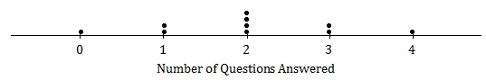

Use the statistical features of your calculator to find the mean and the standard deviation of the data set.

Mean: ____________________

Standard Deviation: ____________________

1. Suppose the dot plot looked like this:

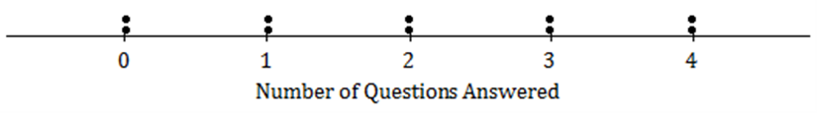

* 1. Use your calculator to find the mean and the standard deviation of this distribution.
  2. Remember that the size of the standard deviation is related to the size of the deviations from the mean. Explain why the standard deviation of this distribution is greater than the standard deviation in Exercise 2.

1. Suppose that all ten people questioned answered all four questions on the questionnaire.
   * + - 1. What would the dot plot look like?

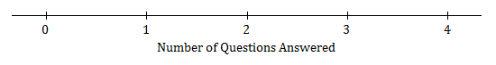

* + - * 1. What is the mean number of questions answered? (You should be able to answer without doing any calculations!)
        2. What is the standard deviation? (Again, don’t do any calculations!)

1. Continue to think about the situation previously described where the numbers of questions answered by each of ten people was recorded.
   1. Draw the dot plot of the distribution of possible data values that has the largest possible standard deviation. (There were ten people at the talk, so there should be ten dots in your dot plot.) Use the scale given below.



* 1. Explain why the distribution you have drawn has a larger standard deviation than the distribution in Exercise 4.